Economic Time Series Modeling of U.S. Housing Prices

Vikas Garg, Yasin Khan, Shirley Lu, Timothy Roberts, Yi Fan Tang, Wesley Tillu
Cornell university, school of operations research & Engineering

Abstract
The unprecedented rise in housing prices within the United States during the last decade has led to an exponential growth in housing valuations and overall US GDP. This phenomenon combined with reckless lending standards, post deregulation, and rock bottom interest rates fuelled the housing bubble and the subsequent recession as we know it today. With the present uncertainty in the housing price market, it’s imperative for financial institutions and hedge funds trading in Mortgage Backed Securities (MBS) to develop efficient and robust forecasting models to understand the housing price process. More importantly, to be able to predict the evolution of housing prices over a medium to long term horizon with the purpose of devising profitable trading strategies.

As a key driver of mortgage rates and valuation, understanding house price evolution is critical to investing in mortgage backed assets. This project utilizes the state level quarterly Housing Price Index (HPI) data provided by the Office of Federal Housing Enterprise Oversight (OFHEO), which is now the Federal Housing Finance Agency (FHFA), as a measure of movement for single family house prices in the United States. The aim of this study is to investigate the presence of long memory in the HPI index and to model the HPI returns as a proxy for housing prices at the state level. This model could then be used to forecast HPI returns to profitably price and trade MBS.

A two phase approach was adopted to model the HPI returns data. Phase I is dedicated to drift modeling and Phase II is dedicated to modeling the residuals, also referred to as volatility modeling. In Phase I we explored the relationship between the HPI returns and major economic indicators (predictors) that affect the housing process, in a time series regression framework. The predictors used to model the HPI were population size and growth, median income (proxy for housing affordability), unemployment rate, foreclosures, mortgage originations, 30 year current coupon (proxy for the cost of credit) and building permits issuance (proxy for housing stock). Leading and lagging values of these predictors were used in the regression to capture the true dependence of HPI returns on these indicators. In analyzing each state’s HPI, the response and predictors were transformed to their simple returns and the data was interpolated from quarterly to monthly. Multiple regression models were developed at the state level to identify significant predictors and to generate robust parameter estimates. Phase II modeling of the ARFIMA/GARCH errors was done when autocorrelated residuals were observed in the time series regression carried out in Phase I. This is done to accommodate volatility clustering observed in the residuals. To generate forecasts for multiple steps ahead, time series models for each of the predictors are created. First, the forecasts for predictors are made and these forecasted values are then fed into the HPI forecasting models developed at the end of Phase II.

INTRODUCTION
This project seeks to understand the housing price process in a discrete time series setting. As key drivers of mortgage rates and valuation, addressing house price evolution is critical to investing in mortgage backed assets. Fundamental considerations relevant to our project scope will include, but will not be limited to, the effect of default and prepayment risk on mortgage pool valuation and the significance of geography in the housing market. Additionally, this project will investigate the presence of long memory in the housing price process, with a specific focus on long memory in housing price volatility.

In general, an understanding of the housing price process should lend itself to a model from which time series forecasts can be derived using appropriate methods and techniques.

Housing Price Economics
A. Demand for Housing
The main determinants of housing demand are:
- Population Size and Growth
- Income
- Price of Housing
- Cost and Availability of Credit
- Consumer Preferences
- Investor Preferences
- Price of Substitutes and Compliments

The income elasticity of demand in North America is 0.5 to 0.9.
Price elasticity of the demand for housing services in North America is -0.9 to -0.7.

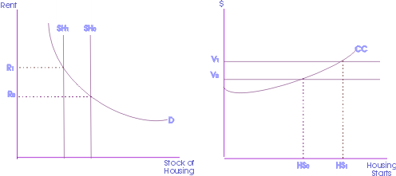
Figure 2.1: Rent and Housing Stock; Value and Housing Starts

B. Supply of Housing
The quantity of new supply is determined by the cost of inputs such as land, labor, and building materials. The price of the existing stock of houses and technology of production has an impact as well.

A typical single family dwelling in suburban North America has the following cost structure:
- Acquisition costs 10%
- Site improvement costs 11%
- Labor costs 26%
- Materials costs 31%
- Finance costs 3%
- Administrative costs 15%,
- Marketing costs 4%

Supply price elasticity depends on the elasticity of substitution and supply restrictions. There is significant substitutability between land and materials, as well as between labor and materials. In high-value locations, multi-story concrete buildings are typically built to reduce the amount of expensive land used.

Supply restrictions can significantly affect substitutability. In particular a supply shortage of skilled labor, land availability, and land use controls.

C. Housing and Economic Indicators
- Existing-Home Sales
- Pending Home Sales Index
- New-Home Sales
- Housing Starts
- Housing Affordability
- Mortgage Purchase Application Index
- Fixed-Rate Mortgage Rate
- GDP
- Consumer Confidence
- Unemployment Rate
- Consumer Price Index
- Producer Price Index
- Retail Sales

D. Market Equilibrium
1) Inelasticity of Supply and Demand
The market equilibrium is affected by elasticity of demand or supply, or the percentage change in one variable given a change in another. The price elasticity of demand for housing currently falls between -0.7 and -0.9, indicating demand for housing is relatively inelastic. This is a logical conclusion considering housing is a necessity good. With the elasticity of demand of housing relatively inelastic, any shift in the supply curve will have an affect on the ultimate market equilibrium. The demand curve may adjust relatively slowly given a change in supply.

The income elasticity of housing demand falls between 0.5 and 0.9, indicating the extent to which housing could have inelastic demand. The primary factor influencing home prices are income levels. Income elasticity of demand measures the effect on demand given a percentage change in income. Home prices are limited in how far they can rise by the incomes of potential buyers. Approximately eighty percent of all homes purchased are done so with a mortgage. The ability to make payments, borrow money, and the cost of borrowing influence how far prices can rise, because potential buyers are unable to qualify for larger loans.

2) Government Restrictions on Rent
In the short run, a controlled rent level below the market equilibrium causes a shortage in apartments. The supply and demanded analysis is indicated in Figures 2.2. Since it is less profitable to build with rental prices below the market equilibrium, in the long run no new building are constructed and the supply shortage magnifies.

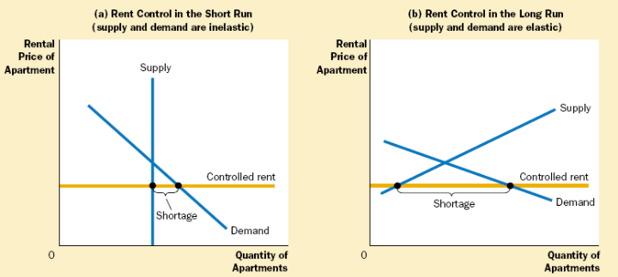
Figure 2.2: Short and Long Run Effects of Rent Controls

A price floor has the opposite effect of controlled rent if the price floor is above the market equilibrium. There is a surplus supply of housing as there are not enough people willing to pay the regulated price of housing.

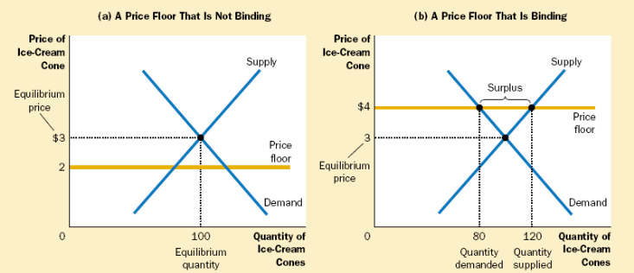
Figure 2.3: Binding and Nonbinding Price Floors

3) Taxes and Tax Credits

A tax levied on buyers causes a demand curve shift downward by the size of the tax. A tax levied on sellers causes a supply curve shift upward by the tax amount. In both situations, the tax causes the price paid by buyers rises, and the price received by sellers to fall. This causes a reduction in the equilibrium quantity, which corresponds to a contraction in market size. In the end, buyers and sellers share the burden of the tax, regardless of how it is levied.

The distribution of the tax burden, incidence of a tax, depends on the price elasticities of supply and demand. The burden tends to fall on the side of the market that is less elastic, because that side of the market responds by changing the quantity bought or sold.

Tax credits aim to have an opposite effect of a tax. Tax credits intend to increase the size of the market, as is the case with the tax credits for the Housing Market Recovery Economic Stimulus Package. Current legislation states that first time homebuyers are eligible for a $7,500 tax credit, given that they purchase the home after April 1, 2008 and before July 1, 2009. This tax credit is essentially an interest-free loan that requires repayment over a period of up to 15 years. In February 2009 Congress passed an $8,000 tax credit for first time home buyers. Note that this credit does not need to be paid back, unlike the original $7,500 first-time homebuyer tax credit. To qualify, the purchase has to be made between January 1, 2009 and November 30, 2009. Additionally, the homeowner must stay in the house for three years.

4) Other Factors of Market Equilibrium
Local economic strength, state and municipal zoning, neighborhood features (such as quality of schools), and the condition of the property itself all play a role in shaping the equilibrium for housing markets.

E. Economics of Housing Bubble
The surplus in housing stock has been created from the era of loose lending standards and low interest rates that has caused a decline in prices. The demand for housing has dropped significantly, because access to credit has deteriorated and the majority of homes are purchased with a mortgage.

The Austrian Business cycle theory claims the bubble was created from a significant increase in borrowing and lack of saving, prompted by overseas borrowing and monetary pumping by the Fed. Housing prices were inflated by the speculative fever, and the prevailing sentiment that housing prices will never drop.

Data and Transformations

OFHEO Housing Price Index
1. Explanation of OFHEO HPI
The OFHEO housing price index measures the movement of single-family house prices. Data is published quarterly, and is available at the state-level from 1975. The index is updated based on repeat-transaction methodology. The data is published by the US Office of Federal Housing Enterprise Oversight (OFHEO) based on Fannie Mae and Freddie Mac mortgage origination data.

One of the advantages of OFHEO data is that it is government collected at the state-level. However, the data does not include jumbo loans and risky subprime sales. The limit on jumbo loans is $417,000, which has been a recent increase, creating hesitation as to the validity of the index to more expensive homes. Moreover, the index is continually updated with every repeat-transaction when new results are released.

2. OFHEO vs. Case-Shiller

The Case Shiller housing price index is an alternative to the OFHEO index. There are a few distinctions between the two indices that merit attention. OFHEO uses both purchase price and refinance appraisals in their dataset, while Case-Shiller does not include refinance appraisals. As mentioned previously, OFHEO data is obtained from mortgage data provided by Fannie Mae and Freddie Mac, while Case-Shiller uses mortgage data from county records.

The weighting methodology of OFHEO equally weights all home prices in the index, while Case-Shiller implements a value-weighted method, giving more weight to higher priced homes. OFHEO covers every state while Case Shiller is missing thirteen states; this is important when some areas are growing rapidly. One advantage of the Case Shiller index is that it is published monthly, which may be important factor considering data such as foreclosures is available at the monthly frequency.

Supply Side Housing Variables
Among the supply side housing variables employed in this project are foreclosures, available housing stock, housing inventory turnover, and building permits issuance.

Foreclosures
Housing foreclosures affects the supply of housing. Foreclosed homes increase the total housing supply available and can affect the prices of neighboring houses. State-level monthly non-agency foreclosure data was obtained from Agamas Capital, who uses the ABS Securities Database as provided by Loan Performance, a First American Company.

The date range for the foreclosure data varies for each state, with the earliest beginning in 1997, while other states did not begin until 2000. The last available monthly data is July 2008 for all states.

Building Permits Issuance
The U.S. Census computes monthly building permits issuance statistics, which are based upon reports submitted by local building permit officials in response to a mail survey, and the Survey of use of Permits (SUP), which is used to collect information on housing starts. When building permit officials fail to respond, the U.S. Census first uses the data from the Survey of use of Permits (SUP), and if this is unavailable, employs their own “imputation” methodology to cover-up the missing data. All in all, the data is sampled from approximately 8,500 of 19,000 permit-issuing places.

An increase in building permits issuance is expected to be highly correlated with housing starts. Therefore, an increase in building permits for a fixed housing demand should shrink housing prices.
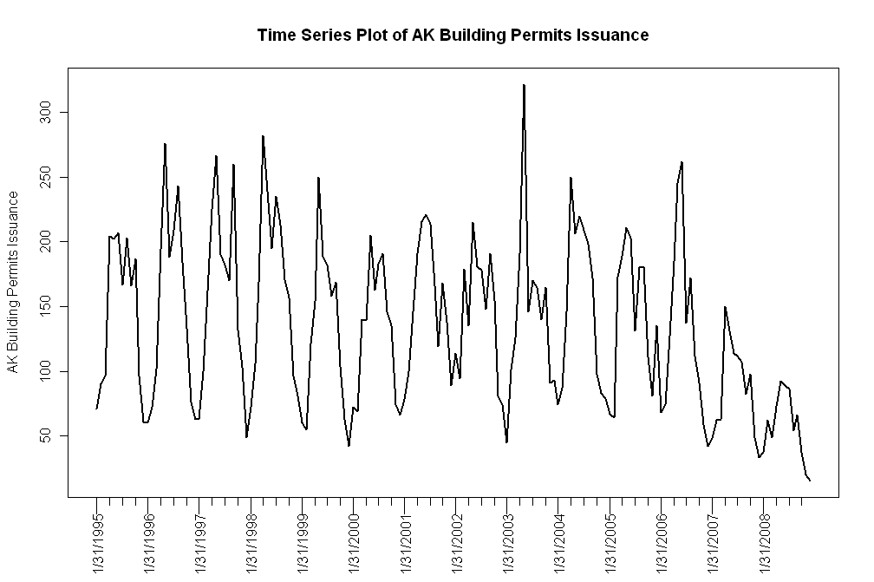
Figure 3.1 Time series plots of building permits issuance.

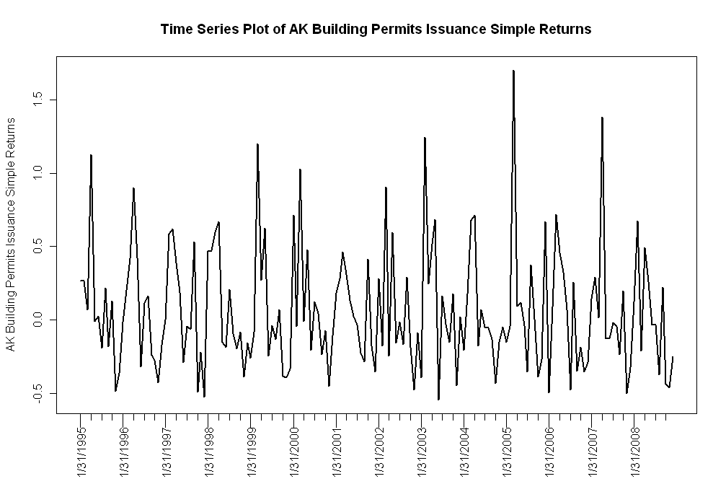
Figure 3.2: Time series plots of building permits issuance simple returns.

Demand Side Housing Variables

Median Income
***

30 Year Current Coupon
One variable that was determined to potentially have effects on the demand for housing is the cost of credit, or the 30-year current coupon rate. The primary source for this data is the Fannie Mae and Freddie Mac agencies. The data is recorded monthly and is at the national level. The data was found using Bloomberg, and the commands used in the terminal are listed below.

Current Coupon: <MCCN>
Fannie Mae 30 Year Coupon: <MTGEFNCL>
Freddie Mac 30 Year Coupon: <MTGEFHLM>

For the regression analysis, the Fannie Mae 30 Year Coupon rate was ultimately chosen. Shown below in Figure 3.3 is a time series plot of the 30-year current coupon rate. The series is plotted with data from December 1984 to February 2009, using monthly data.
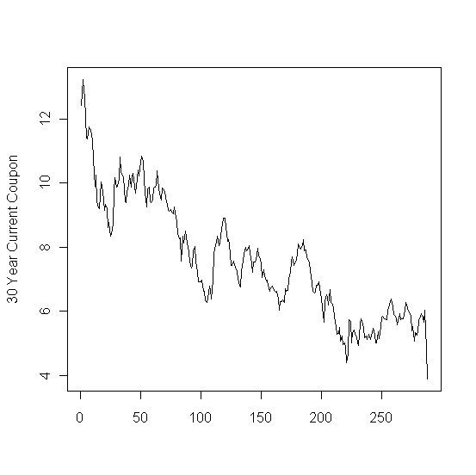
Figure 3.3: Time series plot of the Fannie Mae 30-year current coupon

30 Year Commitment Rate
This variable represents the rate that the secondary market secures to buy mortgages off primary mortgage originators. The agencies lock the originators into a yield for a certain period of time, obligating them to buy these mortgages off their books at a specified yield, for a specific period of time.

The 30-year commitment rate is available from the Fannie Mae and Freddie Mac agencies. The data is recorded monthly and is at the national level. This information was obtained from Bloomberg, and the following commands were used:

Fannie Mae Commitment Rate 30 Year 30 Day: <FNCR3030>
Freddie Mac Commitment Rate 30 Year 30 Day: <FHCR3030>

The rate obtained is also the same rate that is found in Section C of the Wall Street Journal under Secondary Markets, Freddie Mac and Fannie Mae 30 year mortgage yields. The commitment rate given by Fannie Mae was ultimately used in the analysis.

Below, Figure 3.4 shows the time series plot of the commitment rate from March 1983 to February 2009.
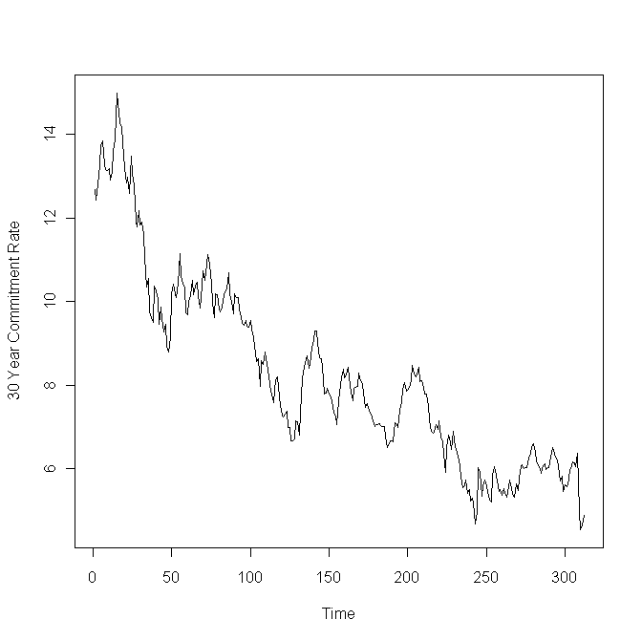
Figure 3.4: Time series plot of the Fannie Mae 30-year commitment rate.

Mortgage Originations
The amount of mortgage originations can be used as an indicator or consumer availability of credit. The availability of credit is a demand-side variable; as credit becomes more easily available, homeowners’ demand for housing increases.

The Mortgage Bankers Association publishes quarterly mortgage originations data on a national level. The data collected ranges from first quarter 1990 to 4th quarter 2008. The data is for 1-4 family home types and is broken out by purchase and refinance mortgages.

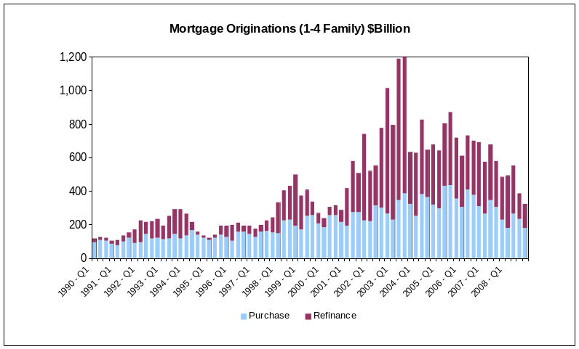

The figure shows that between 1990 and 1994, there was very little refinancing, which is due to high interest rates. Then from 2001 – 2008, every quarter saw a greater amount of refinancing than purchase mortgage financing. The peak for purchase mortgage originations occurred at Q1-2006 while mortgage refinancing peaked in 2003.

More granular mortgage originations data was obtained from Agamas Capital Management. Agamas provided state-level monthly non-agency origination data from September 1996 until January 2008. This data is from ABS Securities Database as provided by Loan Performance, a First American Company.

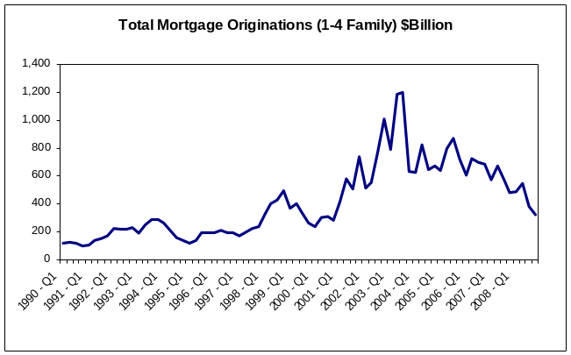

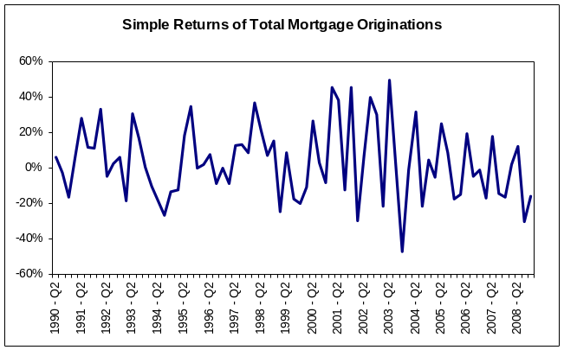

Unemployment Rate
Unemployment can put pressure on the demand for housing. Low unemployment rates indicate a strong and growing economy, which could increase the demand for housing. Conversely, with high unemployment rate, homeowners experience difficulty in making mortgage payments, thus increasing their chances of foreclosure.
Unemployment rates by state were obtained through the Bureau of Labor Statistics. The data is monthly and ranges from 1976 – 2009.

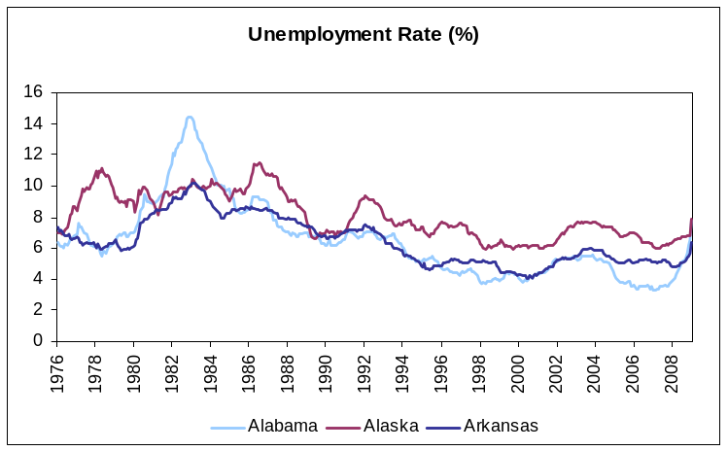

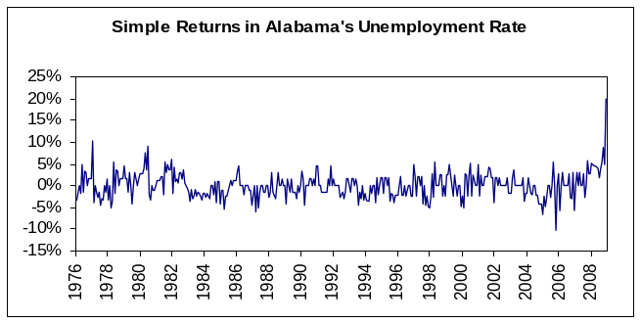

The figure shows that unemployment rate in the period between 1995 and 2007 has been relatively stable and low compared to historical rates, but has seen a steady climb since 2007.

Prime Interest Rate
The prime interest rate is defined specifically as the average majority prime rate charged by banks on short-term loans to business, quoted on an investment basis. The average is computed by rates posted by a majority of top 25 (by assets in domestic offices) insured U.S.-chartered commercial banks. The prime rate is one of several base rates used by banks to price short-term business loans.
The bank prime loan rate was obtained from the Federal Reserve Board. The monthly rate is computed as averages of each calendar day in the month and are annualized using a 360-day year or bank interest.
Historical data is available from January 1949 until February 2009.
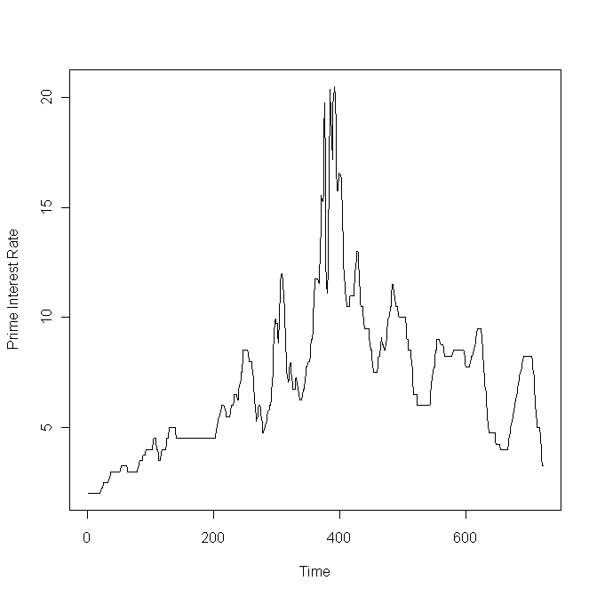
Figure 3.5: Time series plot of the prime interest rate.

Population Size and Growth
Another factor predicted to have an effect on housing demand is the population size. The data was obtained from the U.S. Census Bureau, available on the website at www.census.gov. Population estimates were available yearly, starting from July 1900 to July 2008, both at the state and national level.

The time series plot of U.S. population size is shown in Figure 3.6. Additionally, the population growth is plotted in Figure 3.7.

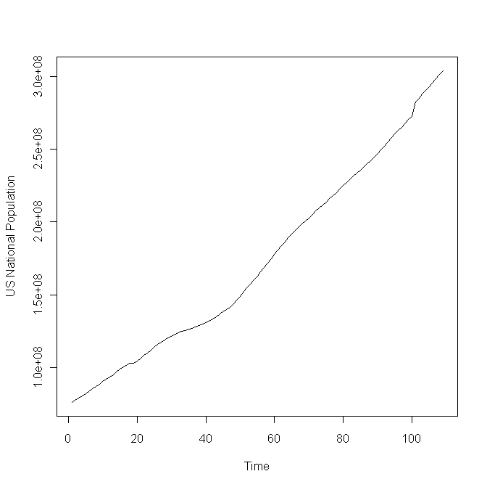
Figure 3.6: Time series plot of U.S. population.

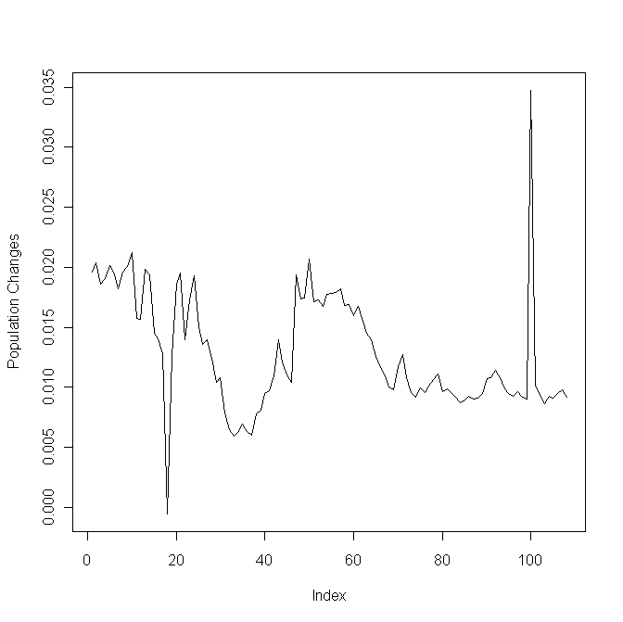
Figure 3.7: Time series plot of U.S. population growth.

Median House Price/Median Income
A measure of housing affordability is the ratio of median house price to median income. A positive trend in this ratio would indicate that homeowners are using a larger proportion of their income to financing their homes.

Median house price and median income data was obtained from the Census Bureau. The data is on a national level on a monthly basis from 1981 to 2008. The ratio was calculated by dividing the median house price by median income for each month.

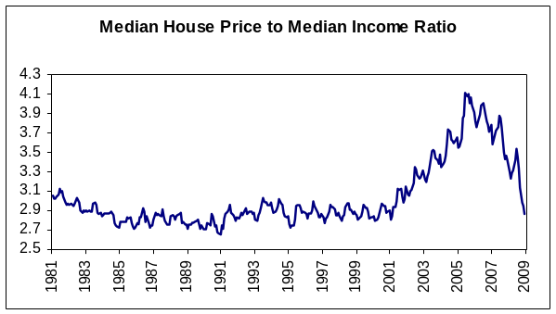

As the figure shows, the ratio increased dramatically starting 2001 and peaked around 2005. This ratio can later be compared to historical averages and a large delta from the historical value would raise concern, signaling that housing is becoming less affordable.
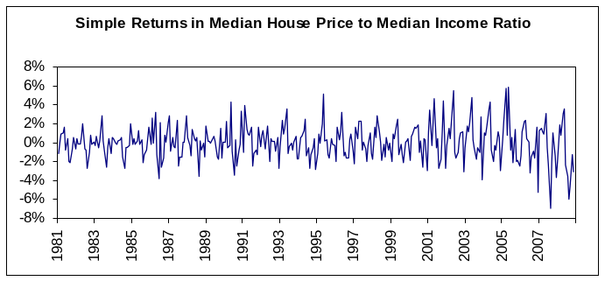

Interpolation and Missing Value Treatment
The Office of Federal Housing Enterprise Oversight (OFHEO) Housing Price Index (HPI) provides quarterly housing price data on a state-level starting from 1975. This quarterly data was interpolated to achieve monthly housing price data. Interpolation gives two benefits: first, monthly data matches the frequency of borrowers’ payment streams, which is the basis for asset-backed securities, and second, interpolation increases our data set from 135 quarterly observations to 402 monthly observations, thus increasing the sample size significantly. Interpolation does have its drawbacks, though, of increasing estimation errors. The selection of appropriate interpolation techniques will aim to minimize such errors.

Two interpolation techniques were analyzed. First, a linear interpolation between each quarterly data point was used to estimate monthly housing prices. Second, a cubic spline interpolation method was implemented on the entire data set. For both methods, HPI’s quarterly observations were fixed so that the interpolated data set matches the quarterly for the corresponding months as to reduce error. A plot of the quarterly and monthly time series shows the interpolation methods to be accurate. See Figure 3.8. The more granular zoomed-in plots show that a cubic spline is continuous and smooth as compared to the linearly interpolated data.
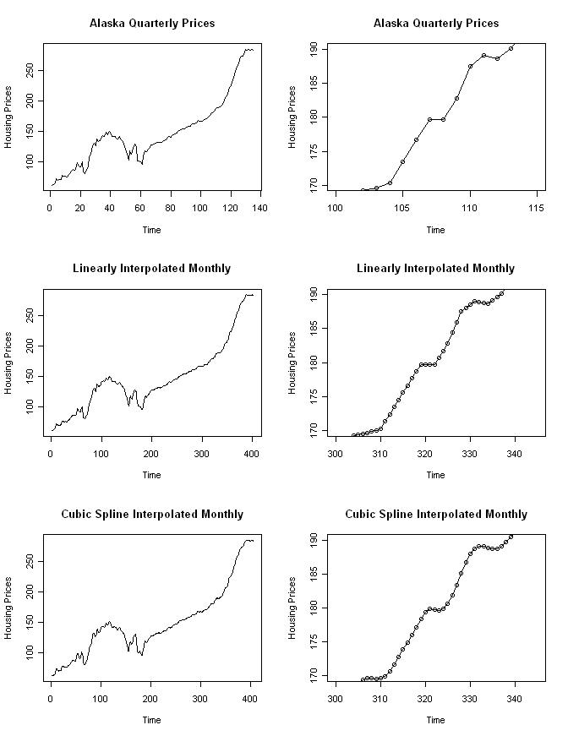
Figure 3.8: Comparison of quarterly with linearly and cubic-spline interpolated monthly prices for Alaska. The plots on the right-hand side shows a zoomed-in version of the original and interpolated data.

Furthermore, the two-sample Kolmogorov-Smirnov (K-S) test was used to statistically check whether the quarterly and the interpolated data sets are drawn from the same distribution. The hypothesis for the K-S test is defined as follows.

H₀: The two samples come from a common distribution.
H_{A}: The two samples do not come from a common distribution.

The p-value for both the linear and cubic-spline interpolation methods was 1, verifying that the data interpolation did not fundamentally alter the original observed data set.

The quarterly and monthly autocorrelation functions (ACF) for the simple returns were calculated and compared to validate that the monthly ACF at lag i approximately equals the quarterly ACF at lag i+3 for all i. Figure 3.8 shows the ACF plots of the quarterly and monthly simple returns. As expected, the monthly autocorrelations peak at every third multiple of where the quarterly autocorrelation peaks. This confirms that no additional autocorrelation was induced in the interpolation process. The monthly autocorrelations also exhibit the same pattern and shape as the quarterly, except with more granularity and precision. The same can be said for the squared simple returns series.

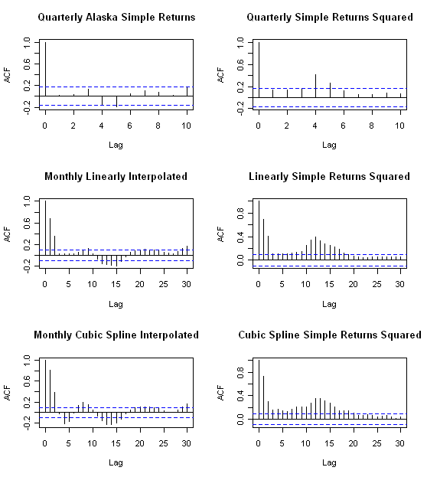
Figure 3.9: Autocorrelation plots of quarterly and interpolated monthly simple returns (left-side plots) and of the squared simple returns series (right-side plots) for Alaska.

Data Range Determination

SAS Treatment of Outliers
The treatment of outliers by the Filter Outlier node in SAS Enterprise Miner was investigated. In essence, SAS will eliminate observations based on the empirical quantiles of the ranked data. Different methods of choosing the empirical quantiles to be eliminated are available, including the Median Absolute Deviation, Modal Center, Standard Deviation, and Extreme Percentiles. Additionally, the desired percentage of the top and bottom quantiles to be eliminated can be specified.

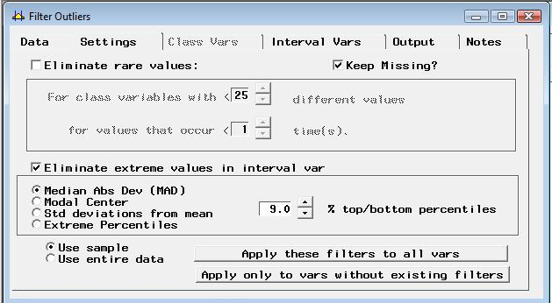

Figure 3.10: Filter Outlier Node in SAS Enterprise Miner

Since our data is a time series, it is not appropriate to intermittently eliminate data points. Our goal is to determine a cutoff point from which we remove prior data for model construction.

Grubb’s Test
A common method of identifying outliers in a data set is the Grubb’s test (also known as the maximum normal residual test). One assumption of the test is that the data set is normally distributed, which is not the case for all the state level simple returns of the OHFEO HPI. Another shortfall of the test is that Grubbs' test detects one outlier at a time at certain significance levels. This outlier is expunged from the dataset and the test is iterated until no outliers are detected.

Grubbs' test is defined for the hypothesis:
H₀: There are no outliers in the data set
H_{A}: There is at least one outlier in the data set

The test statistic is:

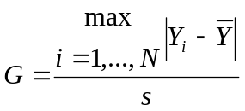

For the two-sided test, the hypothesis of no outliers is rejected at significance level α if:

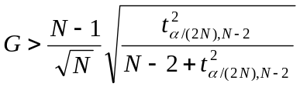

with t_{α/(2N),N−2} denoting the upper critical value of the t-distribution with N − 2 degrees of freedom and a significance level of α/(2N).

The Grubb’s test was performed on the Alaska OFHEO HPIO simple returns. At the 10% confidence level, the returns for second quarter 1980 and second quarter 1989 are considered outliers. Identical results hold for the 5% confidence level. However, at the 1% confidence level, only the simple return for second quarter 1989 is considered an outlier by the Grubb’s test.

Cut-off Determination
It was speculated that the OFHEO housing price index may have varying degrees of data quality. More specifically, the data collection methods before 1990 may have not been consistent, leading to incorrect index levels. This may be evidenced by the extremely high volatility in early periods of the simple return data – up to around quarter 40.

To learn more about any changes in data collection, OFHEO was contacted by phone. Based on the understanding of the OFHEO representatives, there has not been a change in the methodology of data collection for their HPI. It receives quarterly data electronically from the enterprises (ie. Fannie and Freddie), which in turn, is fed directly into their indexing methodology. There is no knowledge or documentation regarding discrepancies in data collection with Fannie and Freddie data; however, any change in data collection might be from the Fannie and Freddie side.

OFHEO noted that as a result of their repeat-transaction methodology, the HPI continues to change to reflect newer data. For example, if a home is sold just once in first quarter 1975, nothing happens to the index. If however, in 2008, the house is sold again, the HPI might be updated both in 1975 and 2008. This might show the index converges to a more "refined" estimate, and gives less cause for error.

Changes in Fannie and Freddie’s data collection process will be further investigated. OFHEO will be providing a knowledgeable contact at Fannie and Freddie, where any data collection changes made have been made.

Treatment of Outliers
While no conclusive evidence was found of any change in data collection methodology, some type of cut-off seemed to be needed. The high variance in the simple returns implies either time-specific volatility or an error / change in data collection methodology. Since there was no evidence of increased volatility in housing prices from 1975 to early 1980s, it was concluded that the volatility was due to the latter reason.

Therefore, looking at the simple return charts for all states, a cut-off point of quarter 40, or the 1st quarter of 1985 was chosen. To be consistent, this cut-off point was used for all states under investigation. The shortened data set for states was used for the remainder of the analysis.

Methods

Exploratory Data Analysis

Stationarity

The initial analysis of the data was carried out as follows:

The simple return series was created from the HPI data and time series plots were generated for all the states. If the simple return series created from the HPI data is stationary then the appropriate AR/MA or the ARMA order is determined (using the Partial Autocorrelation Function (PACF) and the Auto Correlation Function (ACF) plots) and then the model parameters are estimated. If the series is not stationary, it’s tested for unit root stationarity. The first differenced series of the simple returns is created, for series which show the presence of a unit root. Next step is to determine the orders of an ARIMA model for this series. Box-Ljung test is used on residuals to test the adequacy of the model. The test is performed separately for the residuals, and on the squared residuals to test the adequacy of the mean equation and the presence of ARCH effects respectively. Given below are charts prepared for AR, which show a non stationary behavior in the simple return series, and a slowly decaying ACF plot. But the differenced series appears to be stationary.

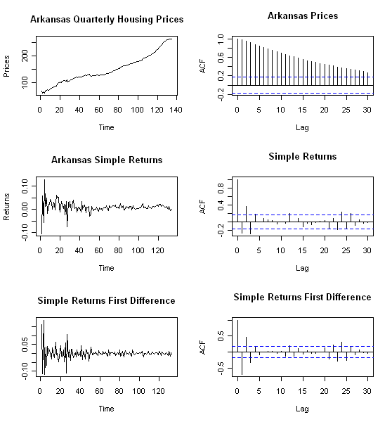
Figure 4.1: Plots and ACF of Arkansas quarterly housing prices, their simple returns, and the simple returns first difference.

Data Transformations

Many parameter estimators are based on the assumption of Gaussian distribution. In particular, the Whittle estimator for the fractional differencing parameter is one such estimator. The Whittle estimator is generally preferred over other fractional differencing parameters as it is consistent, unbiased, and asymptotically efficient.

The Box Cox transformation aims to apply a power transformation to ensure that the data follows an approximately normal distribution. The Box Cox transformation stabilizes variance and induces homoscedacity in the time series. It is defined as

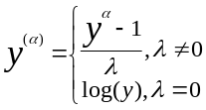

In practice, this transformation is applied to the data before any necessary differencing. Hence, the Box Cox was tested on the original housing price index data rather than their simple returns.
If initial plots of the OFHEO HPI data do not exhibit normality, the Box Cox test was used to estimate the appropriate power of λ along with its standard error. Then, the interval (λ +/- std. error) was evaluated to determine the power to apply. If the interval contained 0, a log transformation was used. Otherwise, the estimate or its closest fraction was used to transform the data.

The effectiveness of the data transformation was tested graphically with density plots and statistically using formal normality tests.

A weakness of the Box Cox transformation is that if the true distribution is far from Gaussian, there will not exist a sufficient λ that will make the data normal. However, even in cases where no power transformation could bring the distribution to exactly normal, the usual estimates of λ will lead to a distribution that satisfies certain restrictions on the first 4 moments, and thus will usually be symmetric.

Analysis of the states demonstrated that the distribution of the returns deviates too far from Gaussian and thus, any Box Cox transformation attempt fails. Figure 5.1 shows graphical results from before and after the transformation for Arkansas and Table 5.1 shows numerical results.
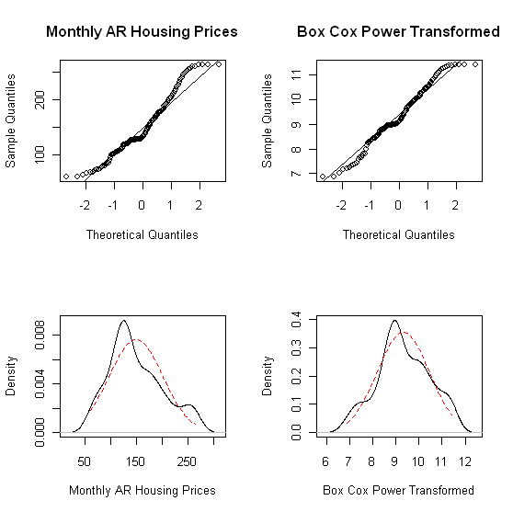
Figure 5.1: QQ plots and density plots of the Arkansas HPI data (left)
and the Box Cox transformed series with λ=0.23 (right)

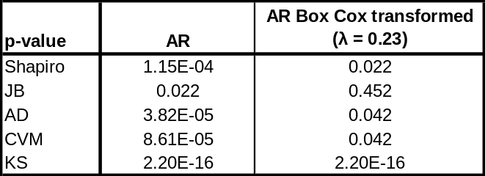
Table 5.1: p-values from normality tests for the Arkansas housing price
series and the Box Cox transformed series with λ=0.23 (right)

The QQ plots and density plots show significant departures from normality. While the Jarque-Bera test does not reject normality in the transformed series, the p-values of the other normality tests strongly suggest non-normal distributions. The Jarque-Bera tests deviations from normal skewness of 0 and kurtosis of 3. Thus, a symmetric and short-tailed distribution with sample skewness and excess kurtosis coefficients near 0 can incorrectly pass the JB test, as was the case here. It is concluded that a Box Cox transformation is inadequate in making the housing price series Gaussian.

I(1) Testing

To test for unit root stationary, primarily, the Augmented Dickey-Fuller (ADF) test was used. The ADF test checks for the presence of unit root in the time series. The hypothesis tests are summarized as follows:

H_{o}: y_{t} ~ I(1), series contains a unit root
H_{a}: y_{t} ~ I(0), series is stationary
where y_{t} ~ i.i.d

The ADF test was implemented using adf.test within R (using the package “tseries”). To determine the lag order, AIC and BIC values were determined for multiple AR models. The lag associated with the lowest of AIC and BIC values was selected.

Additionally, the Phillips-Perron test was added, using pp.test within R, to substantiate test results from the ADF test. The hypotheses are the same as those from the ADF test.

Results of unit root tests are shown in Table 5.2. As shown, the p-values all show the rejection of the H_{o} for the presence of a unit root; thus, these states were determined to be stationary.

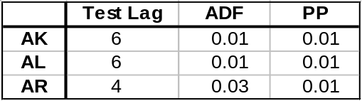
Table 5.2: p-values obtained from applying the Augmented Dickey-Fuller and Phillips-Perron tests to a sample of states

Normality Testing

As stated before, testing the univariate data for normality was an essential part of this analysis, since Gaussian MLE’s such as the Whittle estimate have parametric assumptions about the process under test. Graphical and statistical tests were employed in this study.

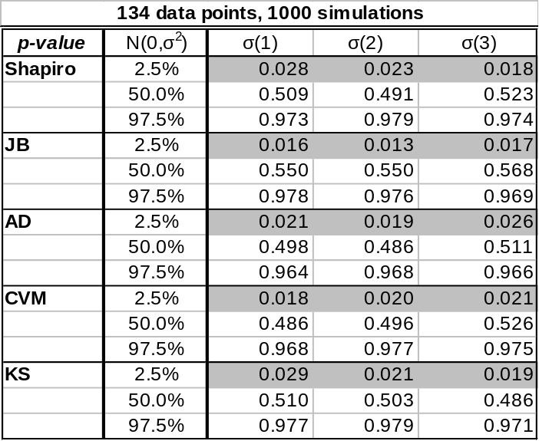
Table 5.3: Normality test p-values for simulated data, 134 data points

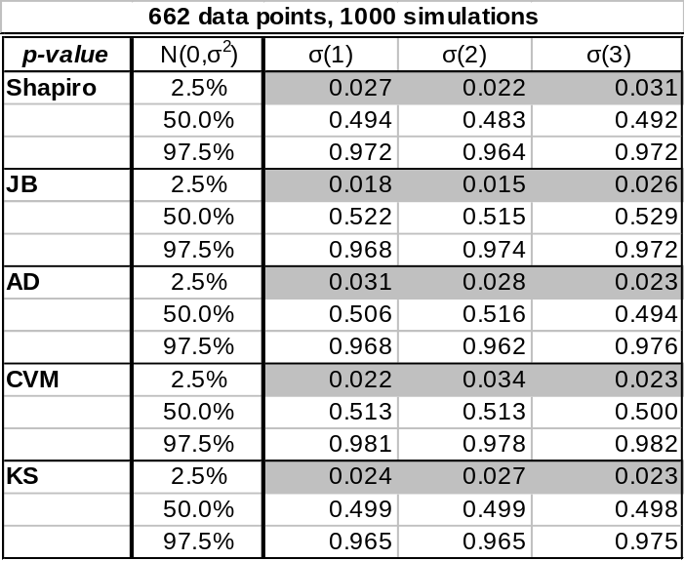
Table 5.4: Normality test p-values for simulated data, 662 data points

Data was simulated from a normal distribution, of both samples sizes 134 and 662, in Table 5.3 and 5.4, respectively. Normality tests were applied to the simulated data and the p-values were recorded. The simulation was repeated 1,000 times and the empirical quantiles of the p-values were recorded.

The purpose of this exercise is to determine the accuracy of the normality tests. The results were expected, with an approximately uniform distribution of p-values. This will be investigated further before conclusions are drawn.

Parameter Estimation for Model Building

Fractional Differencing Parameters

An appropriate investigation of fractional differencing includes entertaining several estimators for a fractional differencing parameter in an ARFIMA (p,d,q) framework. According to Beran, a linear process with i.i.d. innovations can exhibit long memory, however, it is difficult to distinguish the behavior of linear ARMA-type processes from fractionally integrated processes for small values of n, where n is the length of the univariate process under question.

With these considerations in mind, it was necessary to include a fractional integration determination based on the following:

- An efficiency study of different estimators for the fractional differencing d, including “removal of fractional differencing.”

- A formal statistical hypothesis test for fractional differencing. Specifically, Dolando et. al. has proposed a Fractional Dickey Fuller test, in which, in the following regression setup,

Δy_{t} = µ + φΔ^{d}y_{t-1} + A(L)Δy_{t} + ε_{t}

the null hypothesis of unit-root non-stationarity (d=d₀=1) is tested against fractional integration
(d=d₁ ε (-1/2,1/2)).

H₀: φ = 0, y_{t} is FI(d₀)
H_{A}: φ < 0, y_{t} is FI(d₁)

Initial results of this test are promising in simulation, but further investigation has to be carried out to validate statistical accuracy with respect to MARS-derived critical values (see Sephton).

An objective comparison of ARFIMA(p,d,q) (long memory) with an alternative model, using forecast errors.

Fractionally integrated processes of sample sizes 1000 were generated using fracdiff.sim (R package “fracdiff”) from the ARIMA(0,d,0) distribution. The 2.5%, 50%, and 97.5% quantiles for the d values are indicated in Table 2. The GPH estimator (R package “fracdiff”) was used to estimate the fractionally integrated parameter d from the simulated data. Simulations of 1000 were used to construct the empirical quantiles, with the purpose of understanding the accuracy of the GPH estimator.

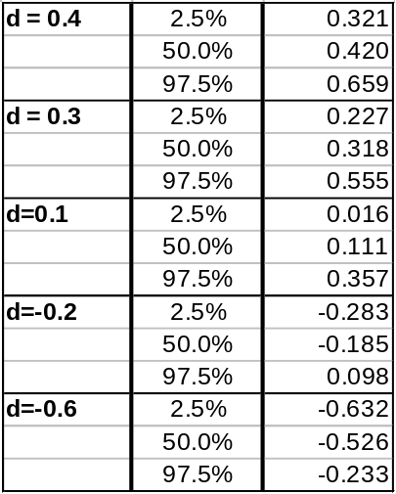
Table 5.5: Quantiles of d-parameter of simulated fractionally integrated processes, determined though the GPH estimator
(n=1,000; Burn-In = 1,000; Simulations = 1,000; ARIMA(0,d,0))

Selected Density Plots:
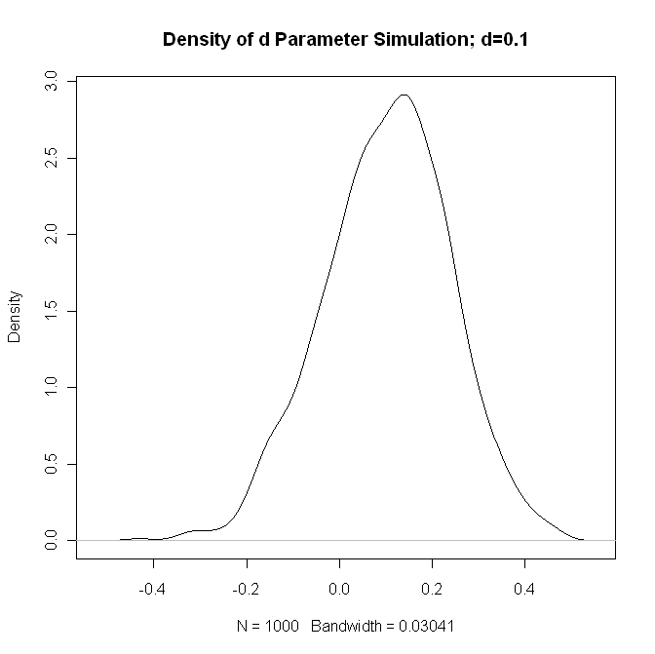
Figure 5.2: Density of GPH estimates of d Parameter,
Simulated data has d=0.1

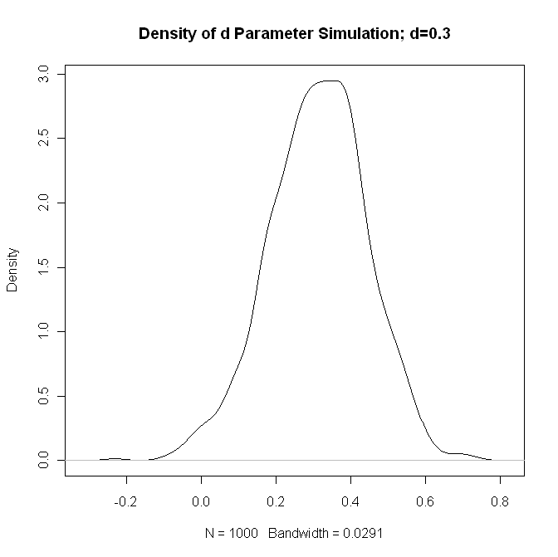
Figure 5.3: Density of GPH estimates of d Parameter, Simulated data has d=0.3

The density plot indicates that the GPH estimator appears to be a reasonable estimate of the fractionally integrated parameter. This is verified by the relatively small variance of the density plots. The accuracy of the GPH estimator will be investigated further by comparing fractionally integrated parameter estimates to the results from other estimators.

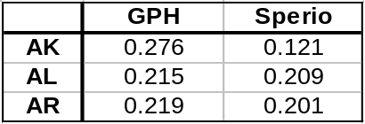
Table 5.6: d-parameter estimates using the GPH and Sperio
Estimates for a select sample of states

Using the GPH estimator as described above, d-parameters were estimated for the selected states. The results are shown above in Table 3. Additionally, d-parameters were estimated using the Sperio estimator, to gauge the accuracy of GPH. Results using the Sperio estimator confirmed the d estimates for Alabama and Arkansas. However, the results for Alaska verified the need for further investigation.

To supplement these findings, a Monte Carlo simulation has been included, where a random ARFIMA (0,d,0) process is simulated 1000 tines, for a series length of 134, where d is the point estimate derived from the corresponding estimation method. The following plot includes point estimates, in black, for the parameter itself, as well as standard errors derived from the asymptotic distributional assumptions of the estimation method. The results of the simulation study are superimposed and shown in blue.

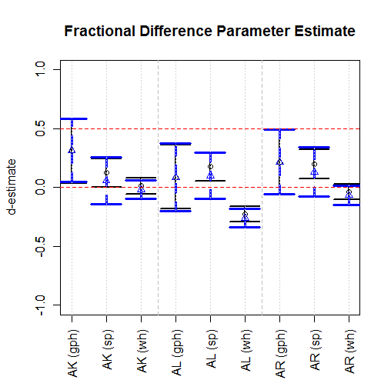
Figure 5.4: d-parameter estimates for AK, AL, AR.

Additionally, included point estimates were included for the fractionally differenced series, anticipating that any degree of fractional integration should be “filtered-out” by taking a fractional difference, using the previous d parameter estimates.
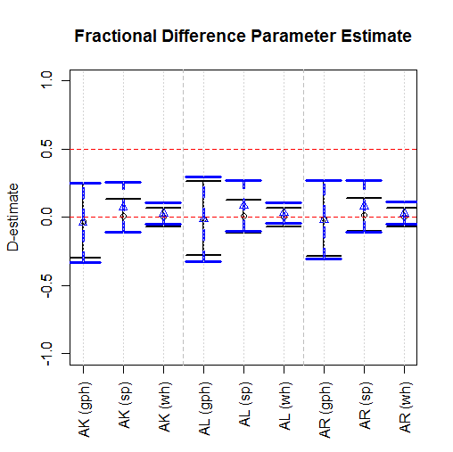

Figure 5.5. D-parameter estimate for fractionally differenced series.

Here, “D” denotes the fractional difference parameter after fractionally differencing each univariate series with the corresponding estimate of d. As expected, all D’s are close to zero.

It is noteworthy, however, that in the case of the most stationary estimate, the Whittle estimate of AK, taking a fractional difference also produces a D=0. Thus, this method of inferring fractional integration vs. unit root or some other type of integration, and may not be sufficient to estimate a suitable estimate for d as well.

This research shows that Whittle Gaussian MLE (Whittle estimators have the lowest estimation errors from simulation. For a complete picture, the following simulation results show ranges of estimates for simulated time series, with corresponding standard deviation. For this reason, we use the Whittle estimator to infer long memory parameters, which are shown in the model specification section.
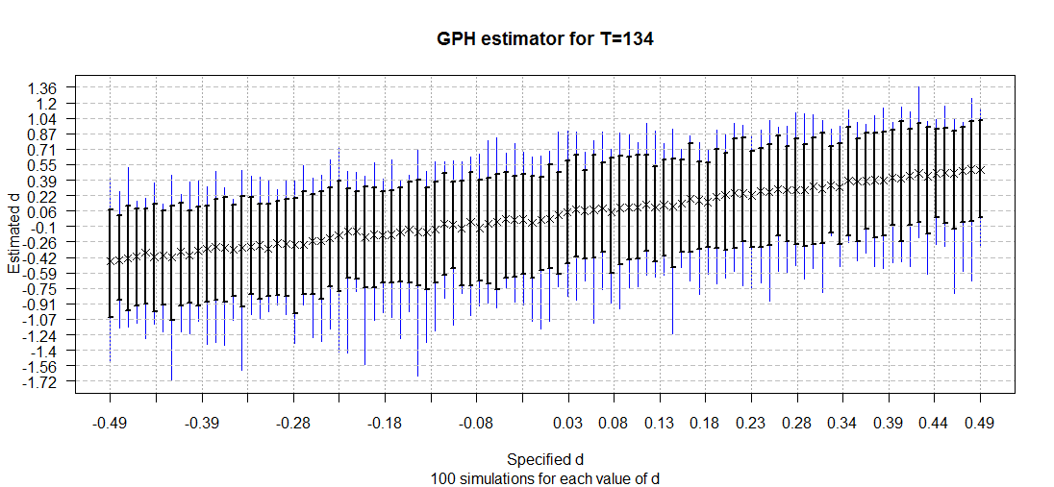
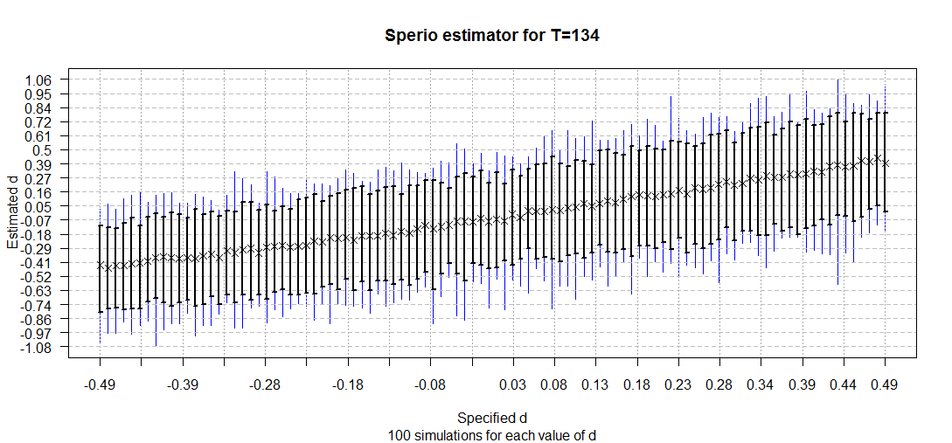
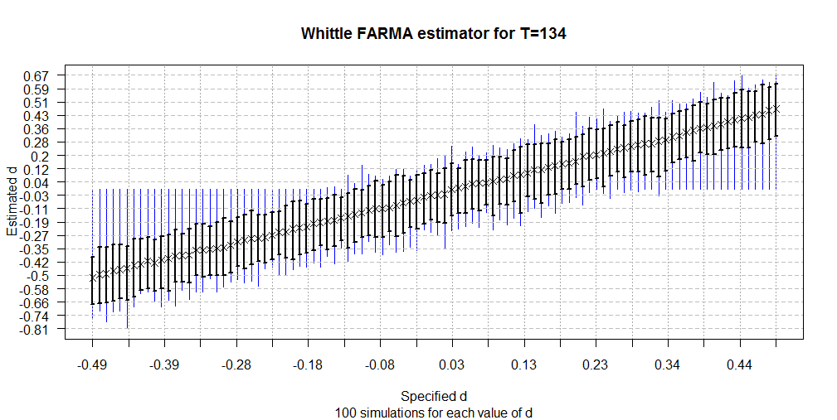
Figure 5.6: Simulated range for d-parameter estimates, showing smallest estimation error for Whittle Gaussian MLE.

ARFIMA-GARCH Model Building

This section shows a typical steps taken for fitting an adequate univariate time series model to OFHEO state simple returns. This sections differs from the preceding analysis, in that we’ve used interpolated and scrubbed data in our analysis for model building.

Of course, checking for unit-root non-stationary is a necessary first step, but this example (“AK”) aims to provide methods for fitting parameter values for a given model. From this analysis, the three states’ simple returns from their respective scrubbed, interpolated indices are best fit with an ARFIMA-GARCH model.

The following provides a summary of the analysis used to derive parameter estimates for the AK, AL, and AR models.

- Investigate the ACF of the simple returns and squared returns.
- If there is persistence in the ACF, take a fractional difference using the Whittle Gaussian MLE and work with this series.
- Check for adequate removal of long-term dependence by inspecting the ACF of the fractionally differenced series and squared fractionally differenced series. Otherwise, try a different estimate for “d”.
- Model the mean equation in an ARMA(p,q) framework.
- Check the ACF of the residuals and squared residuals from iii and check to see if a volatility model is necessary using the Box Ljung test.
- Model the conditional mean and volatility equations jointly in a ARMA(p,q) + GARCH(m,s) framework, using (p,q) from iii.
- Repeat step iv for this new set of residuals, and proceed to iii if necessary.

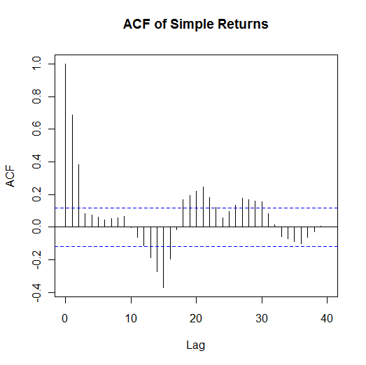 | 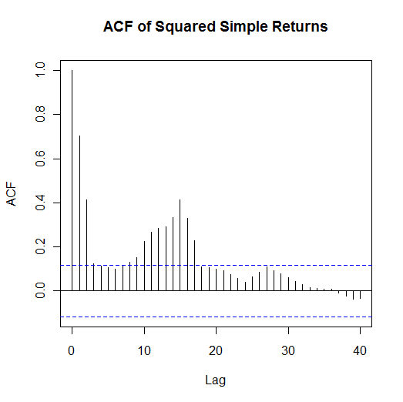
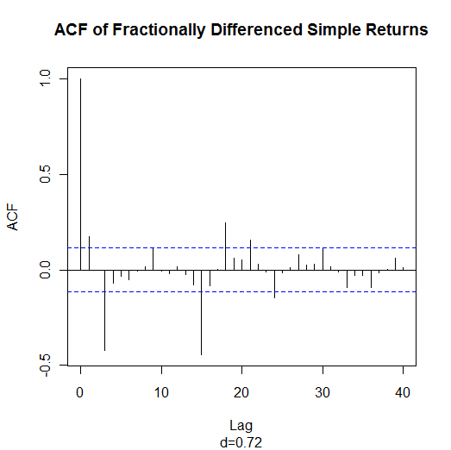 | 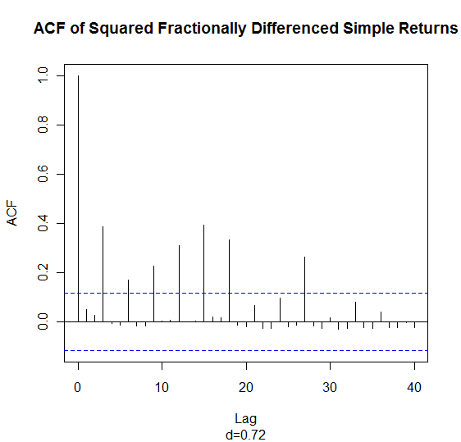
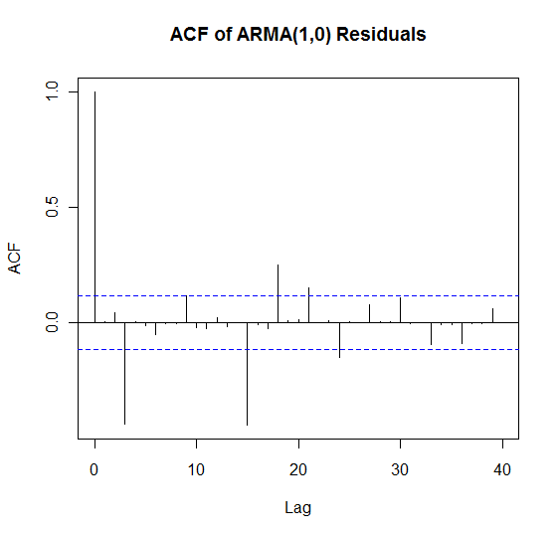 | 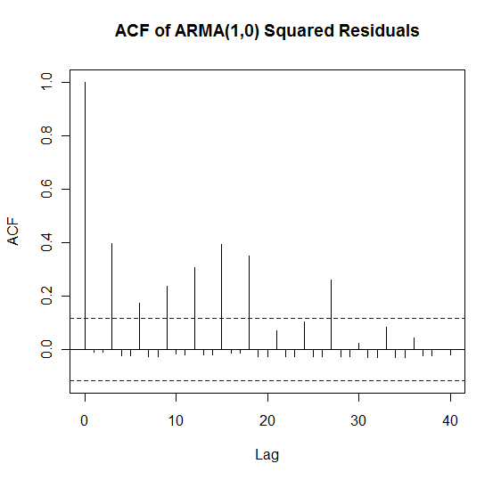
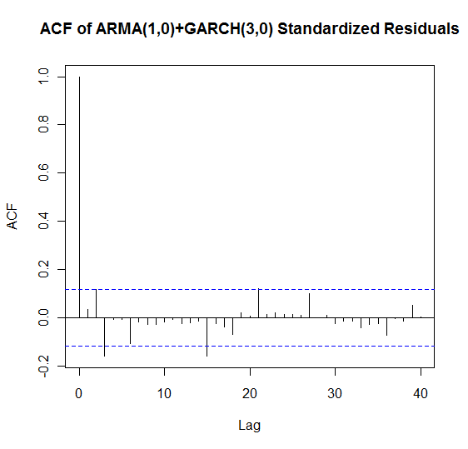 | 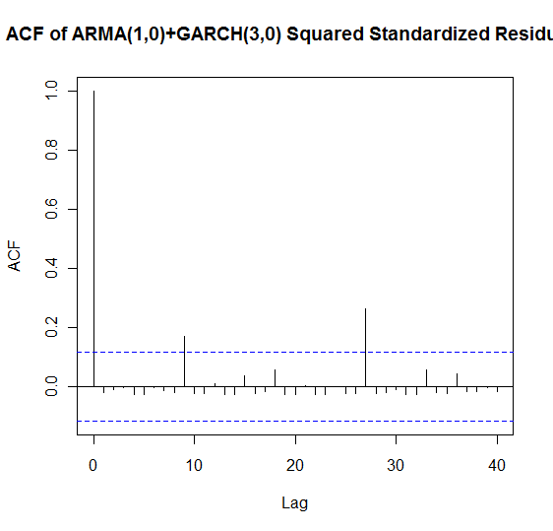
Figure 5.7: The ACF plots of steps i, iii, v, and vii for AK.

The results of the estimation procedure for all three states’ models are summarized as follows, and are of the form:

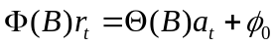
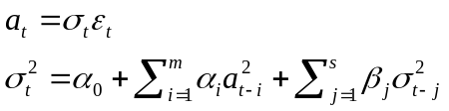
where m,s is the order of a GARCH(m,s) model.

State
Interpolated/Scrubbed Data Models
AK  d=0.72 | Lag | φ | θ | α | β
AK  d=0.72 | 0 |  |  |  | 0.50
AK  d=0.72 | 1 | 0.20
AK  d=0.72 | 2
AK  d=0.72 | 3 |  |  | 1.00
AL  d=0.77 | Lag | φ | θ | α | β
AL  d=0.77 | 0
AL  d=0.77 | 1 |  | -0.21
AL  d=0.77 | 2 |  | -0.13
AL  d=0.77 | 3 |  | 0.35 | 1.00
AR  d=0.70 | Lag | φ | θ | α | β
AR  d=0.70 | 0
AR  d=0.70 | 1 |  | -0.30
AR  d=0.70 | 2 |  | -0.19
AR  d=0.70 | 3 |  | 0.34 | 1.00

4.B.2.2: Parameter values for fit ARFIMA-GARCH models.

Modeling Methodology
Once the data is prepared (i.e. transformed, normalized and treated for influential outliers), we get to the modeling of HPI returns. The modeling methodology is divided into two broad categories:

- Phase I: Drift Modeling
- Phase II: Volatility Modeling

The following section details the methods employed in developing the Phase I and Phase II models separately.

1. Phase I: Drift Modeling

The drift modeling is mainly aimed at determining the relationship between the HPI returns and a set of economic indicators. These indicators have been discussed in the “Data and Transformations” section earlier. A robust multiple linear regression model is created to explain the relationship between HPI returns (as the response variable) and the economic indicators (as the predictors). The method adopted for the robust regression is Huber’s M-estimation.

Huber’s M-estimation (Sandwich estimator)

Huber’s M-estimation is used to develop a robust linear model. It is also referred to as the sandwich estimator because the parameters estimated by this method are between those estimated by running the least square regression on the entire data and those obtained by running the least square regression on the data remaining after completely discarding the influential outliers from the dataset. Huber’s method falls in between these two extremes as it allocates certain weights to each outlier rather than eliminating them from the regression.

There are three steps involved in developing the drift model:
- Determination of lag-ranges
- Identifying the most significant lag for each predictor i.e. the lag showing the strongest relationship with HPI returns.
- Analysis of residuals

Each of these steps is explained in detail below.

Step-1:
This step deals with the determination of lag-ranges for each predictor that shows a strong correlation with the HPI returns, based on the variable relationships described in the “Data and Transformations” section, for e.g. the following plot shows the time trend of HPI (not the returns) and mortgage originations (not the returns) for the state of Texas.

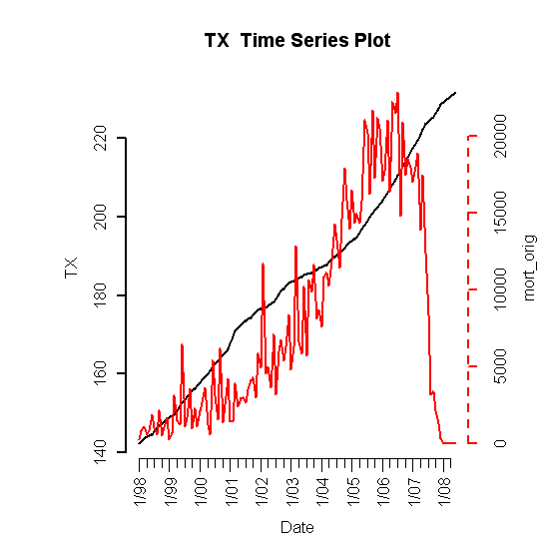

It can be seen that the HPI increases with rising mortgage origination numbers; however the relationship is not contemporaneous and mortgage originations appear to be a leading indicator of the HPI i.e. rising HPI trend, as observed at the beginning of 2008, might be in response to high mortgage volumes sometime in the past. It might in fact be attributed to the mortgage origination trends of period about 0-12 months earlier. So we would like to investigate the relationship between all the lags of mortgage originations, over the range determined by the inspection of the time series plot above, and the HPI returns. One can observe this is an empirical exercise and many a time these ranges will depend on the user experience. The lag-ranges and lead or lag relationships for all other economic indicators are determined in this fashion before going to the step-2 of drift modeling.

Step-2:
This step can be broken down into the following steps:
- All the predictors (simple return transformed) i.e. all the lags of all the economic indicators, determined in the previous step, are fed into a best subset regression with HPI returns as the response. The best subset regression ranks the models based on Bayesian Information Criterion (BIC) values. It is calculated as follows:
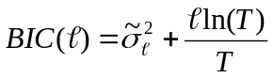
Where “” gives the number of parameters in the model.

From the best subset regression output we pick the model with at least one lag of each predictor variable and which is also among models with low BIC values. This helps to refine the lag-ranges of each economic indicator.
- After coming up with reasonable ranges for each predictor, we manually run a robust multiple linear regression with the new set of predictors (lags of economic indicators) and the HPI returns as the response.
- Our aim is to zero down on the most significant lag of each economic variable and eliminate all other lags from our final regression equation. We achieve this by removing the most insignificant predictor in each regression run by inspecting the t-statistic of this predictor in the regression output with critical t-value at α = 0.05.
- After dropping the most insignificant predictor we re-run the regression with the remaining set of predictors and again follow the same procedure to get rid of the next most insignificant predictor and so on till we are left with only one lag of each predictor, representing each economic indicator, in our drift model. In this exercise we work under the constraint that there must be at least one lag of each economic variable present in the final drift model and accordingly we decide if a particular lag of any variable is to be dropped from the model or not.
- Finally we arrive at the following drift model.
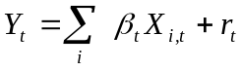
Here “X” represents the most significant lags of the economic variables and “Y” is HPI returns, r_{t} represents the residuals of the fitted model.

Step-3:
Ones the multiple regression model is developed the final step is to check for the model adequacy. The following checks are employed to ensure this:
          - The sign of the coefficients of the predictors make economic sense i.e. the signs of the coefficients must be consistent with the variable relationships, between HPI and the economic variables, explained in the “Data and Transformations” section.
          - Check if the model fits the actual HPI return series. For this we plot the fitted values and the actual returns series on the same plot to observe the adequacy of the fit as shown in the following plot.

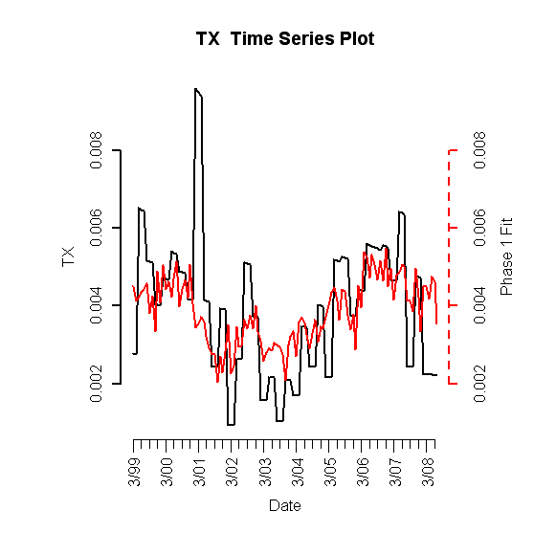

          - The residuals of the fits are checked for stationary. This is done by running the Advance Dicky Fuller (ADF) test on the residuals of the fitted values. If the ADF test fails we have to re-fit the model using different lags of the predictors till the ADF test of stationarity passes.
          - The residuals also should not be autocorrelated, to ensure that the assumption of homoskedasticity is met. This is done by inspection of the ACF plots and by running the Box Ljung test on the residuals and squared residuals. If the residuals are autocorrelated i.e. if they fail the Box-Ljung test then we move to the Phase II of the modeling process called the volatility modeling of the residuals.

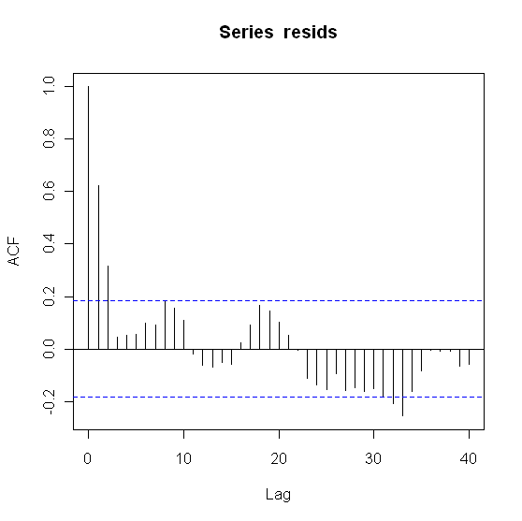

2. Phase 2: Volatility Modeling

Volatility modeling is done to model the serial autocorrelations in the residuals obtained from Phase I. The original residuals used in this stage should already be stationary as is ensured by the carrying out the ADF test at the end of drift modeling stage.
The volatility modeling is divided into following stages to fit an ARFIMA/GARCH time series model to the residuals from Phase I:
- Estimation of the fractional differencing parameter “d” for the given state and create a fractionally differenced series if required.
- Fitting an Auto Regressive Moving Average (ARMA) model to the fractionally differenced series and checking for model adequacy.
- Developing a Generalized Auto Regressive Conditional Heteroskedasticity (GARCH) model, if required, to capture volatility clustering and ARCH effects in the residuals obtained from the ARMA fit in step (ii).

Step-1:
In step-1 of fitting the ARMA model to the stationary residuals we start with the residuals from Phase I that are autocorrelated but are unit root stationary, as shown in the plot below.

First we have to determine if the given series has to be fractionally differenced. This is done by calculating the Gewek and Porter-Hudak (GPH ) estimate for “d”, also called the fractional differencing parameter. If the value of d-parameter is less than 0.5 then we need to fractionally difference the series before fitting the ARMA model. Note that if d-parameter is greater than or equal to 1 then the Phase I model is not adequate and requires a re-fit, as the series is still unit root non-stationary.

Step-2:
In the next step we fit the ARMA model to the fractionally differenced series (if d<0.5). This is done by obtaining a crude estimate of the autoregressive (AR) and moving average (MA) parameters by inspecting the Extended Autocorrelation Function (EACF) plot. From here onwards model fitting becomes a trial and error exercise and one has to fit the best ARMA model by specifying a combination of AR(p), MA(q) and “d” parameters (p,d,q) for the model. Ones the model is fitted it is checked for the adequacy by using the Box-Ljung test on residuals and squared residuals of the ARIMA fit.
- If the residuals do not pass the Box-Ljung test then the mean equation of the ARMA fit is not adequate and AR and MA parameters i.e. (p,q) of the model have to be re-estimated and the model re-fit and re-tested for adequacy. This procedure is followed till an adequate fit is obtained.
- If the squared residuals fail the Box-Ljung test that implies presence of ARCH effects and conditional heteroskedasticity in the ARFIMA(p,d,q) residuals, which calls for GARCH(α,β) modeling.

Step-3:
The failure of Box-Ljung test for squared residuals brings us to step-3 of Phase II modeling. Here we try to fit a GARCH(α,β) model to the residuals of the ARFIMA model fitted in the last step. This is done by trial and error to pick appropriate values of α and β to fit the GARCH model. This model is combined with the ARIMA fit obtained in step-2 to get an ARIMA(p,d,q)/GARCH((α,β) time series model. The model is given as follows:
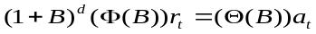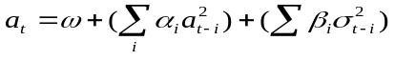;
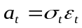
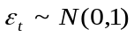
We again apply the Box-Jung test to the residuals of this model to test for model adequacy. The test should pass for both the residuals and squared residuals. The ACF plots of the residuals with ARIMA(p,d,q)/GARCH((α,β) fit for one of the states are shown in the plot below, clearly they are not autocorrelated anymore.

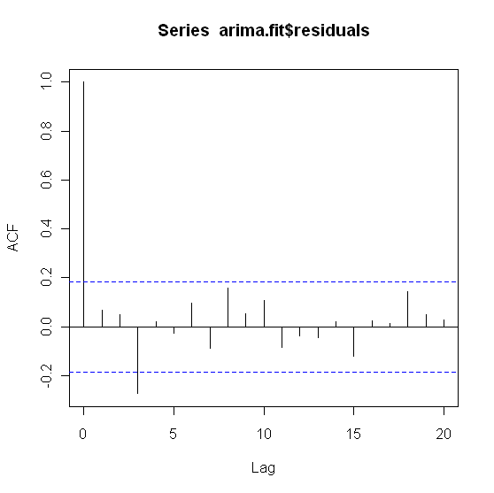

Model Checking and Forecast Performance
1. Checking Fits / Residuals of Overall Model
a.
b.
2. Forecast Performance

Temporal Holdout and Box Ljung Test
Model checking was performed using temporal holdout, in which the model is partitioned at some initial percentage of the data, and this data is used to estimate a new model to create a forecast. The analysis was repeated for the three states for forecasts of 1 and 10 steps ahead, starting with 80% of the original data.

We can see a significant jump in the RMSE for the two respective prediction intervals, as well as consistent order of RMSE among the 1 and 10 step ahead forecasts, for all three models.

At each point after 80%, the model is re-estimated and a new forecast is derived. The model is checked for adequacy using the Box Ljung test, which tests for the existence of zero serial correlation (white noise) in the following hypothesis:

H_{o}:ρ_{i}=0, i ε {1..m}
H_{a}:ρ_{i}≠0, i ε {1..m}

where ρ_{i} is the autocorrelation at lag i, and m is the total number of lags tested.

Results

Variable Forecasts

1. Curve Fitting Qualitative Assumptions
In general, our forecasts were largely based-upon qualitative assumptions regarding the eventual bottom of the housing market in 24 months relative to the second quarter of 2008. This applies mainly to the issuance of building permits, mortgage originations, and foreclosures. Other assumptions include cyclicality of macroeconomic variables (unemployment rate) and long term growth at historical rates (population size, median income).

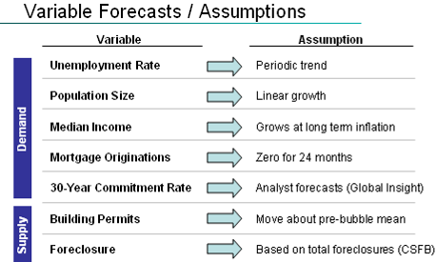
Figure I.3: Qualitative Curve Fitting Assumptions

These assumptions were generically employed in fitting n-degree polynomials to the tail behavior (most recent 2- or 3-year trend), with appropriate convexity constraints and/or data inputs where applicable. The following sections highlight the technicalities of curve-fitting these assumptions for each variable, using Texas as a sample state for illustration.

2. Building Permits
After de-trending the building permits issuance by looking at simple returns, it is evident that there is a seasonal autoregressive behavior. Thus, a reasonable projection was created by fitting a seasonal autoregressive model of the form
INSERT S. AR MODEL HERE from TSAY
to the first part of the data, and by recursively predicting values by using the pre-bubble mean as a starting point.
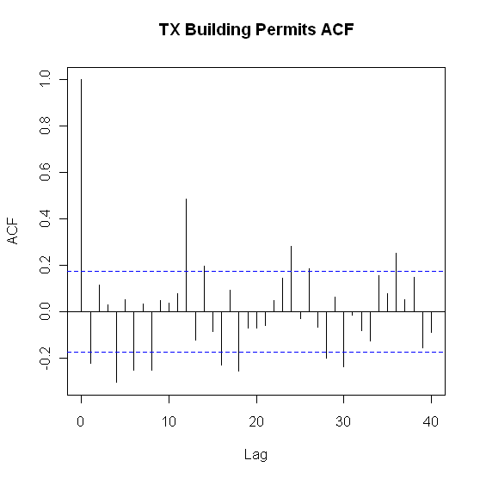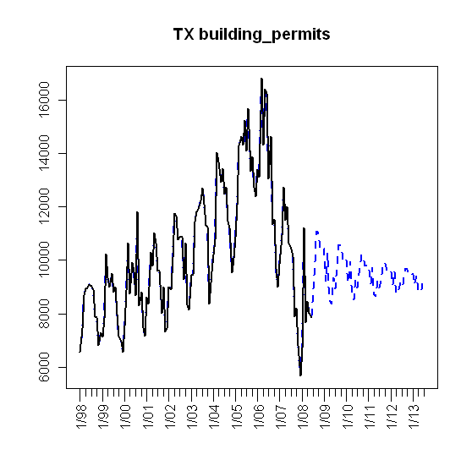
Figure I.4: Building permits simple returns autocorrelation function and curve-fit projections

3. Foreclosures
In predicting the number of foreclosures, the curve fit for foreclosures per month included aggregate yearly analyst estimates from CSFB for the next five years (a very convenient horizon for this study) [6]. State-level estimates were computed from these national aggregates using constant percentage assumptions for total foreclosures at the state level for 2008 obtained from the Center for Responsible Lending [7]. These state-level aggregates were fit using a cubic polynomial, and differenced to obtain monthly changes, which is the format of the original regressor.
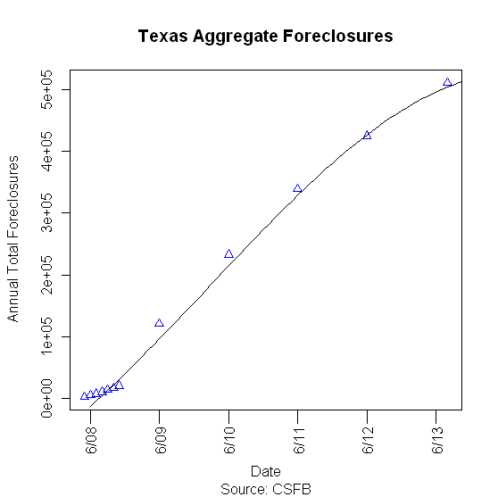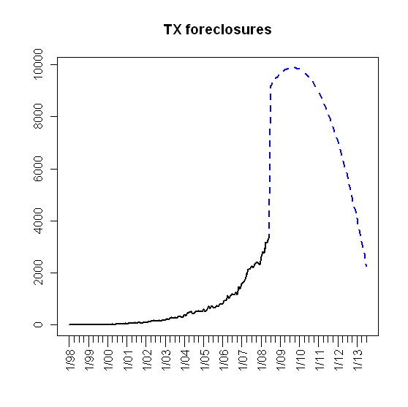
Figure I.5: Aggregate analyst estimates with curve fit (left) and differenced monthly aggregate estimates (right)

4. Population Size
Population size was a relatively simple and intuitive projection. Essentially, population for each state has exhibited a linear growth, so the sixty-month projection was an extrapolation of the long term linear growth rate.

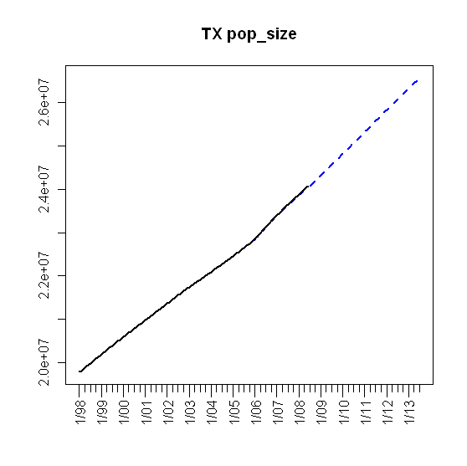
Figure I.6: Linear population size projection.

5. Unemployment Rate
In this study, we assumed periodic unemployment rate, which is consistent with macro-economic variables that are subject to business cycles. As a result, a concave second order quadratic was fit to the last observation, second quarter 2008. As of May, 2008 at the time of this study, the unemployment rate is in consistent with this projection, at 6.3% compared to 6.7%. As an aside, the forecast is lower than actual, which would explain a slight over-prediction of the Texas HPI for the third and fourth quarters of 2008 (see “Forecasts”).
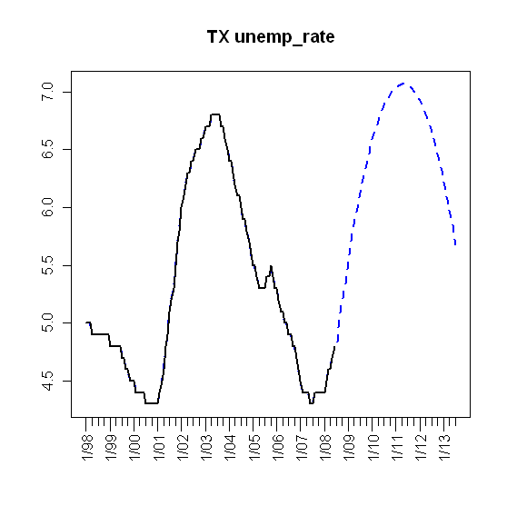
Figure I.7: Periodic unemployment rate projection.
6. Mortgage Originations
Using loess in R, the initial part of the monthly mortgage originations curve [36 months] was smoothed and fit to a constant projection of relatively flat originations (24 months) to give a 60-month forecast.
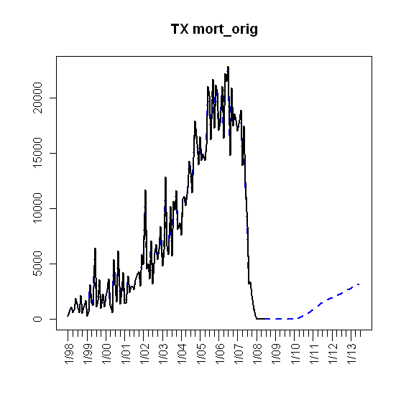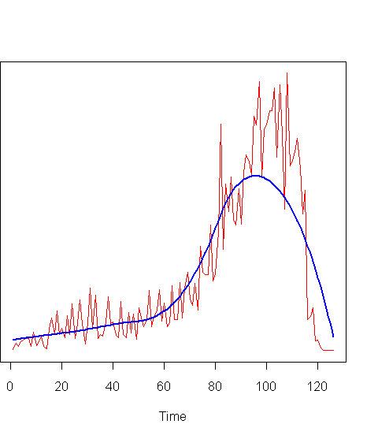
Figure I.8: Periodic unemployment rate projection.
7. Thirty Year Commitment Rate
The thirty year commitment rate projections were obtained via linear interpolation of Global Insight analyst estimates over the next five years TOMMY INSERT REFERENCE HERE. Since this rate is common to the entire nation, this curve was employed in every state’s regressor projection.
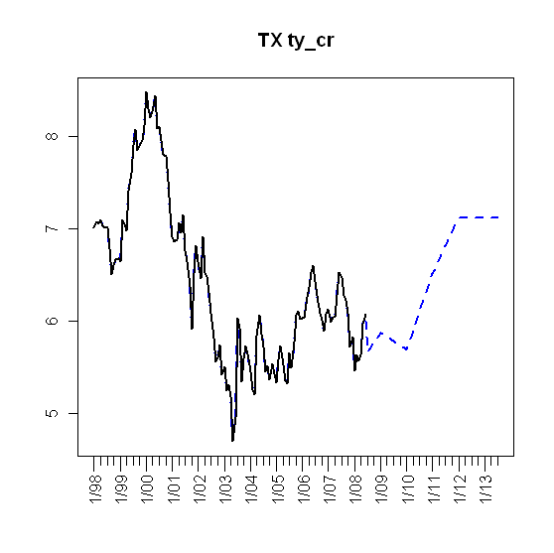
Figure I.9: Thirty year commitment rate projections.
8. Median Income
Median income projections were obtained by assuming a constant, linear growth at average inflation over the next five years, which, by consensus estimates, is 1.7%. Although the next year or two will experience deflation, the projected five year average will be somewhat below historical inflation levels of 3%. In order to keep our individual state results as unbiased as possible, this constant growth rate was applied to each.
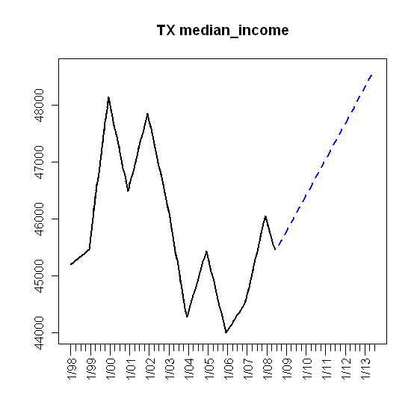
Figure I.10: Median income projection.

Select State Results

1. Arizona
a. Introduction
Phoenix and its suburbs are among the hardest hit by the foreclosure crisis. Avondale, just west of Phoenix, doubled in residents between 2000 and 2005. Now residents are unable to sell their houses except at fire-sale prices. In a case study done by the Wall Street Journal, appraisers valued a house at $132,000 for a $103,000 mortgage, sight unseen, before the housing bubble burst. Under foreclosure the house recently sold for $18,000.

Arizona is a state plagued with negative home equity. In the Town of Maricopa, 75% of all homeowners owe more on their mortgages than the current value of their homes. This is a substantial number compared to the national estimate of 18%.

The Obama administration’s government assistant program will only help you refinance your mortgage if you owe between 80% and 105% of your home's value. Since Arizona is one of the worst hit areas where homes prices have plummeted far below the level of many mortgages, the program will not offer much reprieve to Arizona residents. The Federal stimulus plan offers up to an $8,000 tax credit for anyone who hasn't owned a home for at least three years and the new home remains the buyer's "main home" for at least 36 months after the purchase date. However, this is unlikely to alleviate the

"The foreclosure problem in Arizona is only going to get worse," comments Fred Karnas, the new director of the Arizona Department of Housing. Arizona is currently the state with the nation's third-highest foreclosure rate. On the demand side, there has been a recent drop in building permits for homes across metropolitan Phoenix.

Moreover, the state economy has dependence on three industries that led the nation into recession: construction, housing and financial services. Analyst’s forecast an increase in home prices and sales is unlikely to happen until 2012.

b. Plot of Lagged Predictors vs. HPI (simple returns)
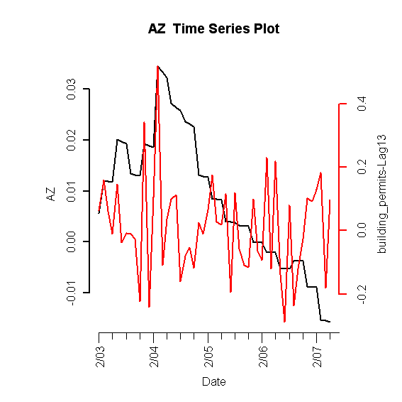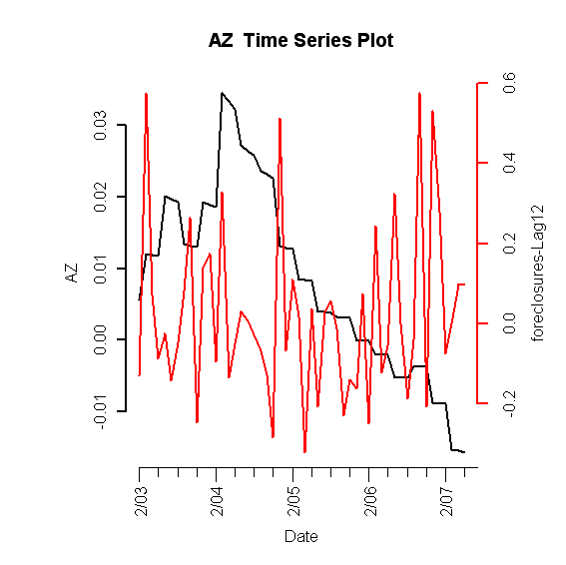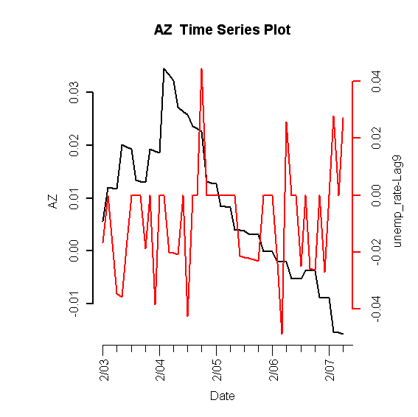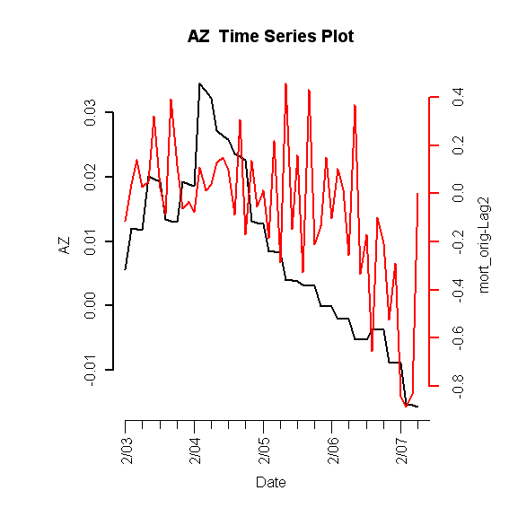
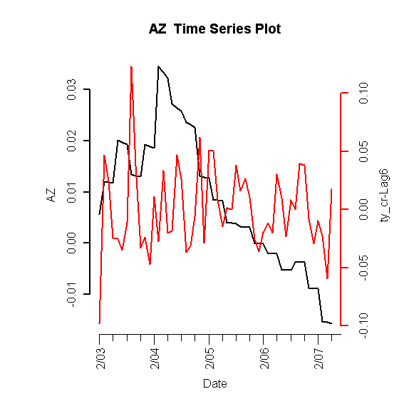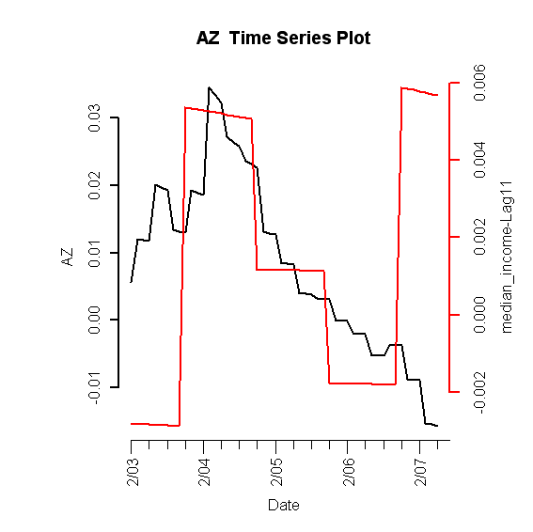

Figure I.11: Lagged predictors vs. Arizona HPI

c. Final Multivariate Model

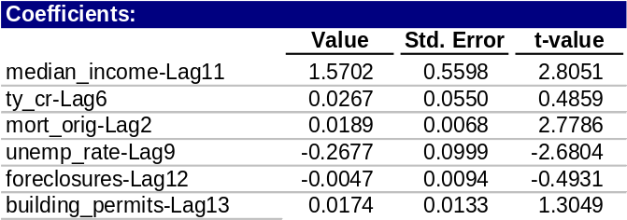
Table 1: Fitted drift model

1. Phase I: Drift Model

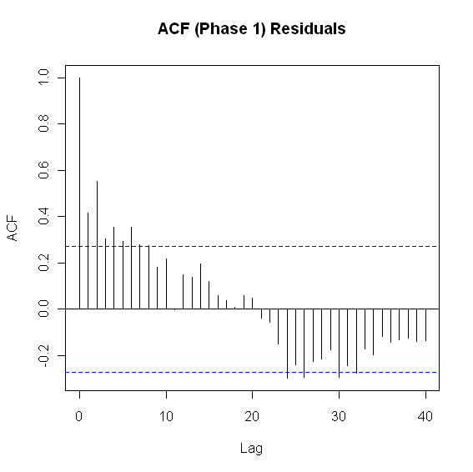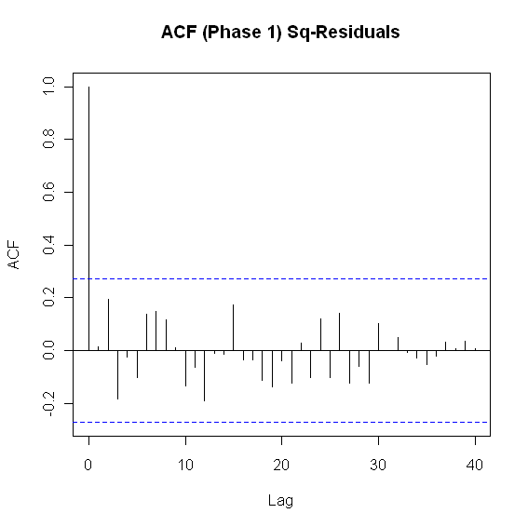

Figure I.12: ACF of residuals (left) and squared residuals (right) of fitted linear model

2. Phase II: Volatility Model

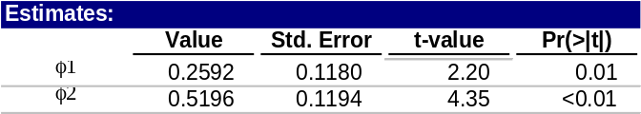
Table 2: Idaho fitted volatility model

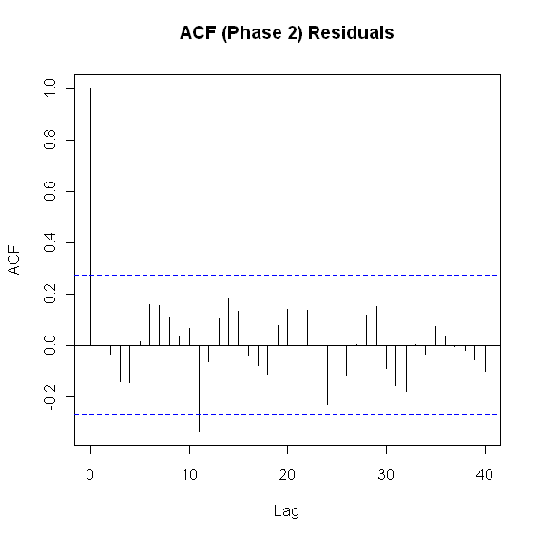

Figure I.13: ACF of residuals (left) and squared residuals (right) of the Phase II model for Idaho

3. Model Checking Diagnostics

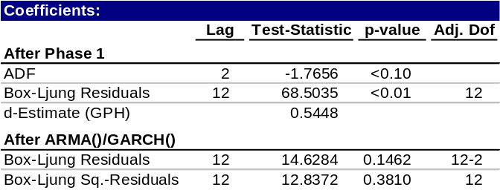
Table 3: Statistical test results for complete model

d. Fitted vs. Actual Plots

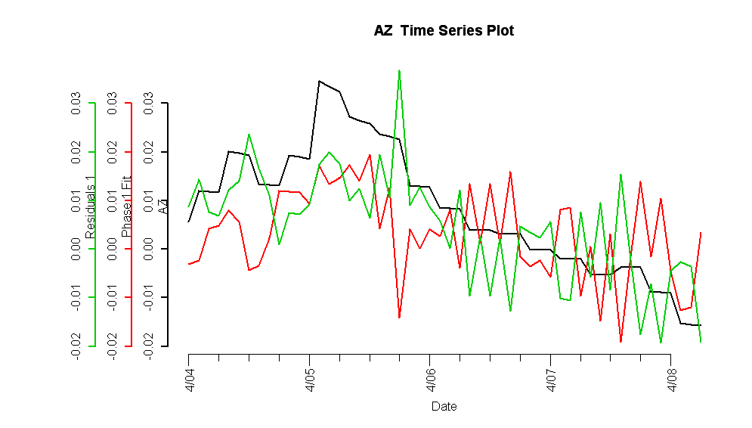
Figure I.14: Fitted Phase I vs. Arizona HPI and residuals

Figure I.15: Complete fitted model vs. Arizona HPI and residuals

e. Forecasts
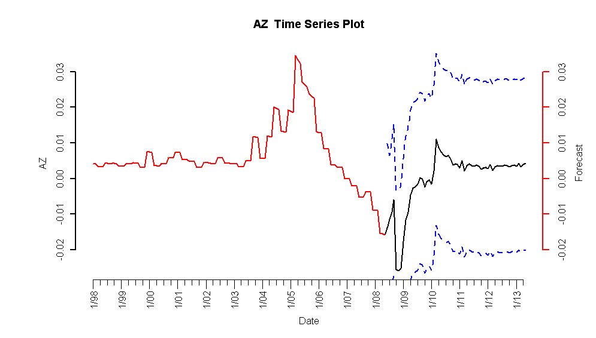
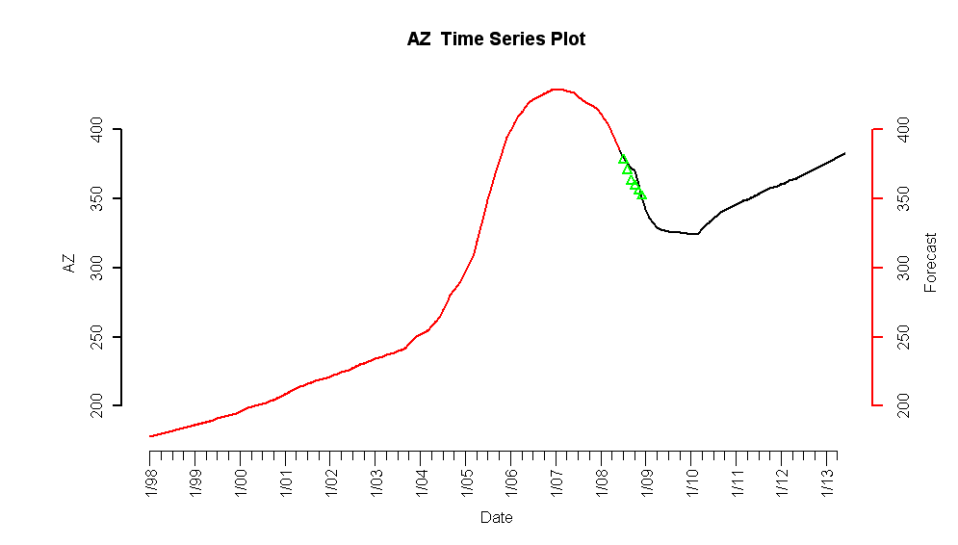

Figure I.16: 5-year forecasted simple returns (top) and forecasted HPI (bottom)

f. Interpretation of Forecasts

The model forecasts indicate a decrease in the HPI until 2010, at which point the simple returns move into positive values. This is in consensus with analyst forecasts and validates our model, given that the realized increase in building permits will have a smoother uptick. Furthermore, the third and fourth quarter 2008 observed values are similar to our forecasts.

2. California

a. Introduction

Similar to other states with a high-foreclosure rate, California has also experienced an extended housing slump. For one, a few indicators show that the homeowner quality has been poor.
- Pre-foreclosures have jumped by a high 80% in the first quarter of 2009, signaling that another wave of foreclosures may be coming. Recently, the temporary freeze on foreclosures, or moratoriums, in California was lifted, catapulting foreclosure numbers higher in March. The latest data shows that foreclosures earlier in the quarter were suppressed, and the end of moratoriums is allowing lenders, like Fannie Mae and Freddie Mac, to clamp down on the mortgages.

- In addition to pre-foreclosures, the delinquency rate has also been on the rise. In some areas of California, delinquency on homeowner associations has reached almost 15%. The effects of delinquencies are cyclic, as homeowner associations provide employment to those in the community.

- In California, the effects of the housing downturn have started to move to previously unaffected areas. During the first quarter of 2009, there were around 315,000 default notices, a 80% increase from the previous quarter. Notices of default have increased to around 35% in some major cities, like San Francisco and Los Angeles. This is another signal of poor homeowner quality affecting California.

In addition to the homeowner quality, the general economic downturn has affected the housing market. New home construction is at a 25-year low, signaling lack of confidence in the real estate market. The unemployment rate is currently around 11.2%, one of the highest in the nation, which slows the road to recovery.

While the current climate of California’s real estate market may be grim, the future outlook is mixed. There are signs the California is on its way to an eventual recovery.
- The first quarter of 2009 showed an increase of 64% in sales of existing single-family homes, as compared to the same period last quarter. This is coupled with the fact that median home prices are on the rise month-over-month, for the first time since August of 2007.

- At the federal level, legislation has been passed to provide an $8,000 tax credit to first-time home buyers for homes purchased between January and November of 2009. Additionally, the state of California has passed legislation allowing a state tax credit of $10,000, on or after March 1, 2009. The particular legislation, Senate Bill 15, has the potential of helping over 10,000 buyers purchase new homes. The tax credits act as stimulus for potential homebuyers, and an increase in home construction will stabilize the housing prices.
- Reflecting the federal and state tax credits, the homebuilder sales rose around 15% in the West part of California. The increase in homebuilder sales is also a sign of recovery.

However, even with certain signs of recovery, there are reasons for continued concerns. As mentioned earlier, the ending of moratoriums by Fannie and Freddie has increased the number of foreclosures and pre-foreclosure notices. This could outweigh the signs of recovery, as well as the existing tax breaks obtained from legislation. In addition, the unemployment rate mentioned earlier is still high, which may delay housing-market recovery and add even more foreclosures. Furthermore, some critics of the tax credit legislations say that the tax credits discourage purchases of existing foreclosed homes. There are many available homes that have been foreclosed, but the tax credits only apply to purchases of new homes.

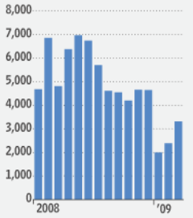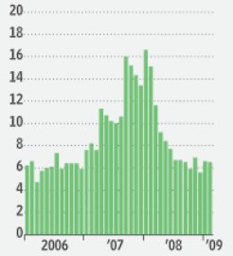
Figure II.17: Total residual permits issued in California (left); Months needed to sell existing inventory at current sales prices (right)

Looking at Figure I.1, the left plot shows that during the 1st quarter of 2009, there has been an increase in housing construction. However, that is juxtaposed with the figure on the right, which shows that the months needed to sell existing inventory has been stable for the past few months. This exhibits that the while construction has been rising, housing inventory has remained stable, which provides support for critics of housing tax credits.

b. Plot of Lagged Predictors vs. HPI (simple returns)
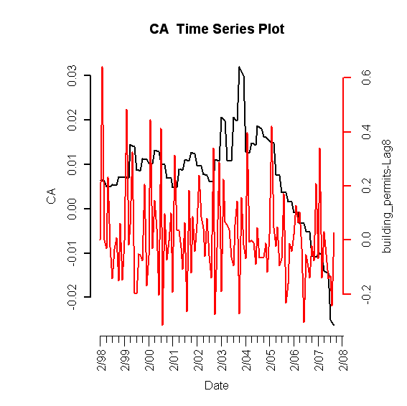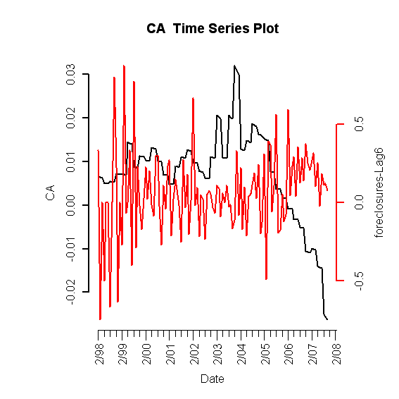
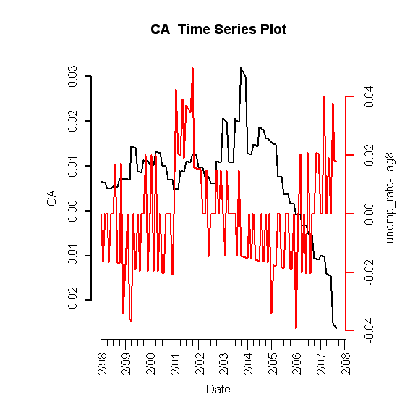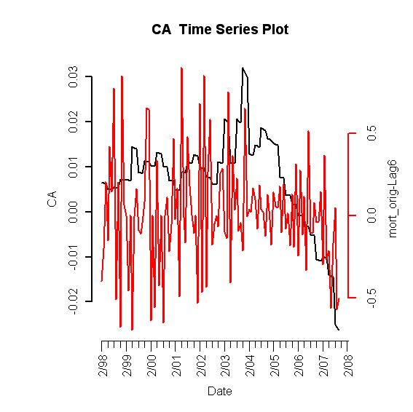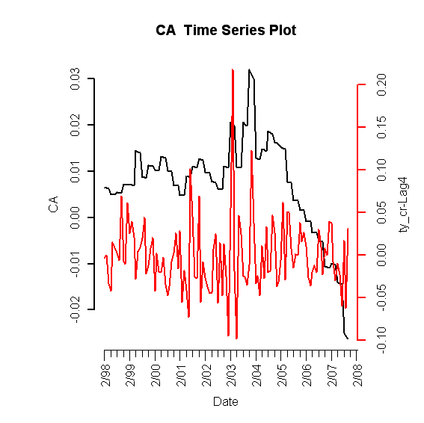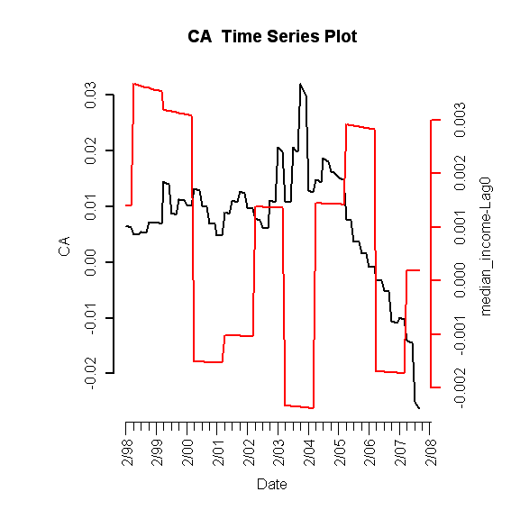

Figure II.18: Lagged predictors vs. Idaho HPI

c. Final Multivariate Model

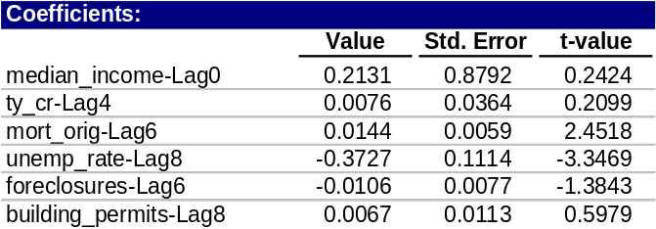
Table 4: Fitted drift model

1. Phase I: Drift Model

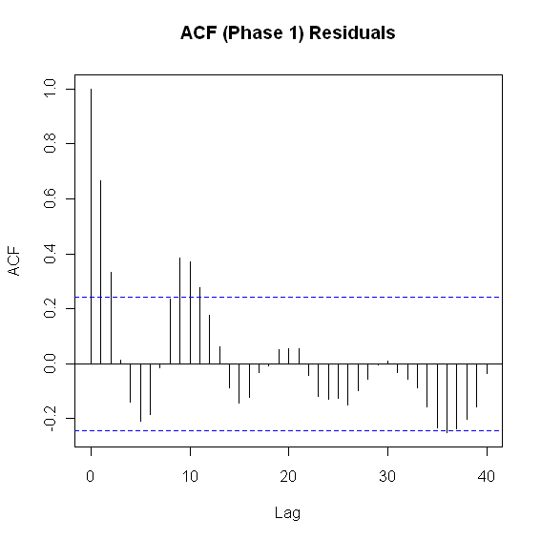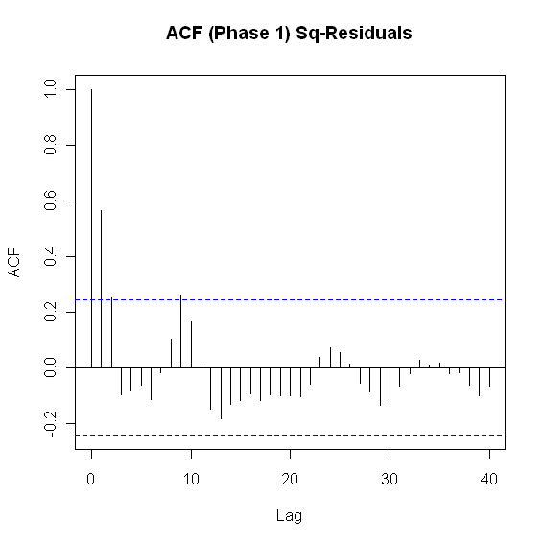
Figure II.19: ACF of residuals (left) and squared residuals (right) of fitted linear model

2. Phase II: Volatility Model

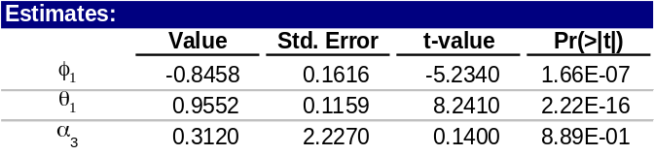
Table 5: California fitted volatility model

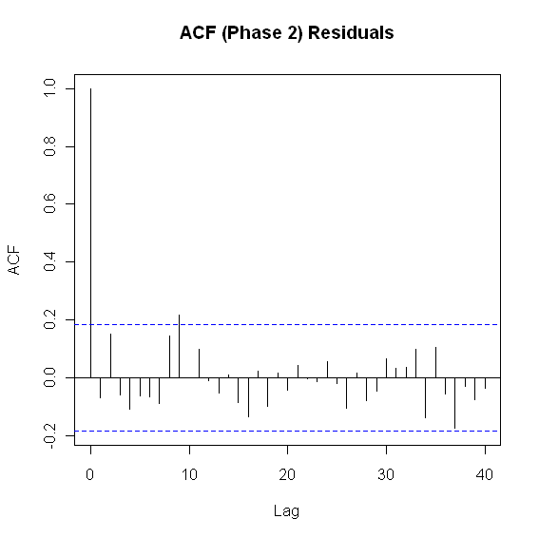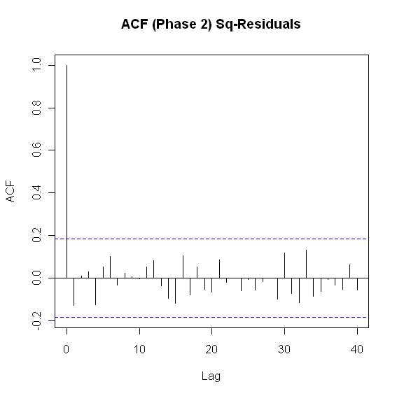
Figure II.20: ACF of residuals (left) and squared residuals (right) of the Phase II model for California

3. Model Checking Diagnostics

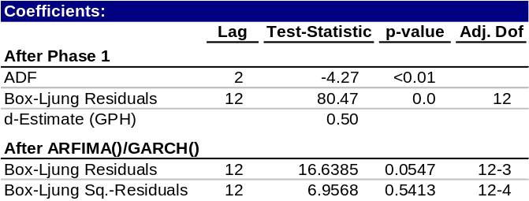
Table 6: Statistical test results for complete model

d. Fitted vs. Actual Plots

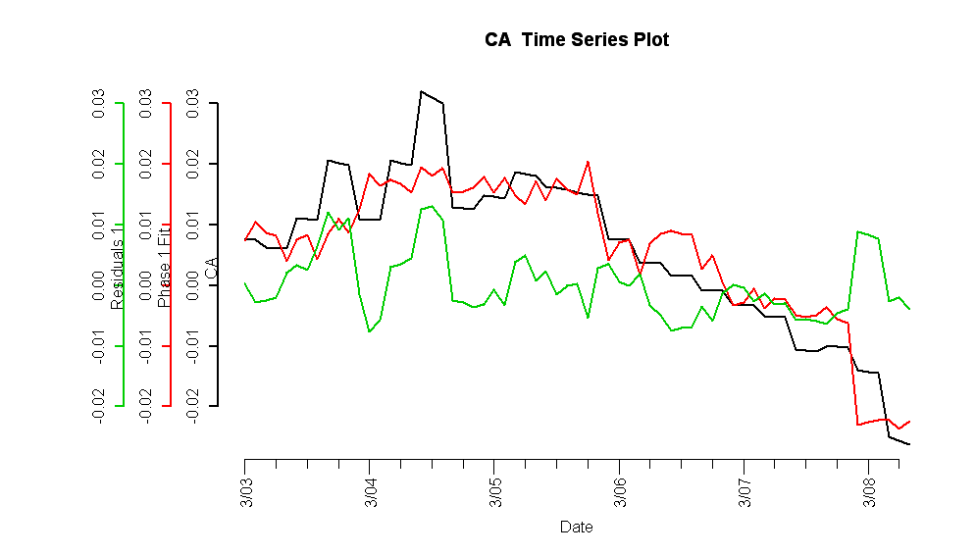
Figure II.21: Fitted Phase I vs. California HPI (red) and residuals (green)

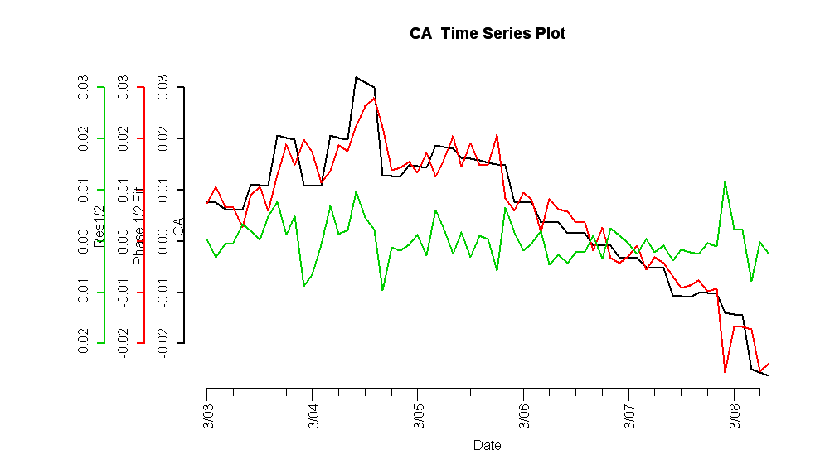

Figure II.22: Complete fitted model vs. California HPI (red) and residuals (green)

e. Forecasts
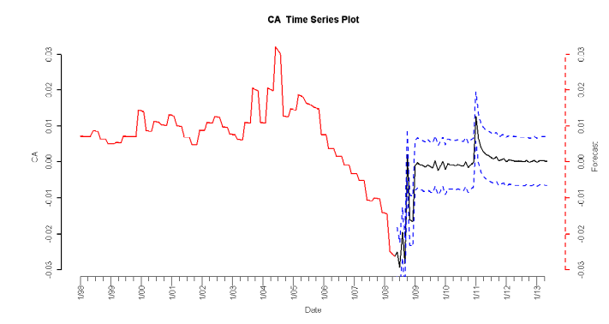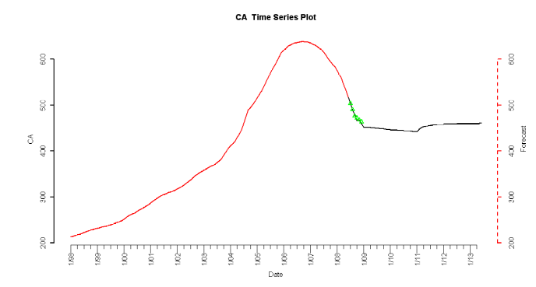
Figure II.23: 5-year forecasted simple returns (top) and forecasted HPI (bottom)

f. Interpretation of Forecasts

As seen in the simple return plot on top of Figure I.7, the simple return remains in negative territory until mid 2009, and then hovers around the zero mark. At around the beginning of 2011, the simple returns begin to increase above the zero line. Similarly, in the actual HPI forecasts, the HPI is projected to decrease after 2008, but the rate of decrease is slowed. The forecasts show that by 2011, the HPI has a reversal and begins a slow upward trend.

The forecasts seem in line with the current outlook of California. As mentioned, there are signs of recovery but at the same time, presently, there are still continued concerns. With the unemployment rate and the increasing foreclosures, the housing market downturn is still taking its toll on the state. This is reflected in the continued decrease of the HPI. However, the rate of decrease is dropping, which indicates that there may be signs of a change. With the tax credit as well as increase in single-family homes, California is on its road to a slow recovery. By 2011, the model predicts that there is ultimately a turnaround.

3. Florida

a. Introduction

The economics of the Florida real estate market is different from other states, especially the other bubble states such as California and Arizona. There are three main differentiations to point out: (1) international investors, (2) concentration of luxury million$ homes, and (3) abundance of vacation homes.

First, Florida’s housing market has a large percentage of international investors, and is ranked first of all foreign home-buying transactions at 26%. California, the second-ranked state, is more than 10% below Florida. Table III.7 shows the top five states for foreign home buyers, as compiled by the National Association of Realtors. Most of Florida’s housing’s international investors are from Europe and Latin and South America. Florida is a major gateway for visitors to the United States from other countries, and cash-rich international investors are attracted to the location, climate, and relatively cheap housing properties of Florida. This extra source of investors can buffer against any downward housing price pressure.

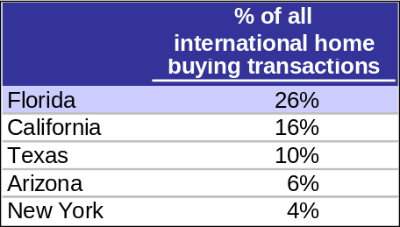
Table III.7: Top Five State Destinations for International Home Buying

Second, Florida has some of the priciest homes in the nation with a large concentration of homes pass the million-dollar mark. These wealthy owners are less affected by the mortgage of credit problems that other Americans face. However, it is important to note that the OFHEO Housing Price Index does account for any homes greater than a value of $417,000. Nevertheless, the abundance of luxury homes attracts wealthy homeowners who may own other homes as well.

Finally, many Americans own vacation homes in Florida, which keeps a healthy stream of demand for houses. Florida is consistently ranked in the top three of an annual poll conducted buy Harris Corporation as where most people would like to live as shown in Table III.8. Furthermore, people who own a vacation home are less likely to take on a speculative mortgage or a mortgage they cannot afford. These owners tend to have more cash than the average homeowner.

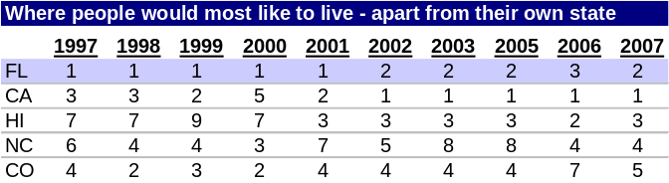
Table III.8: Harris Poll’s “Most Desirable Places to Live” Annual Survey

These characteristics of Florida’s housing market act as a safeguard for the prices of Florida houses, especially in times of declining prices.

b. Plot of Lagged Predictors vs. HPI (simple returns)

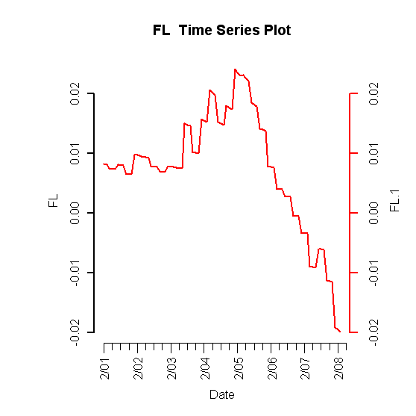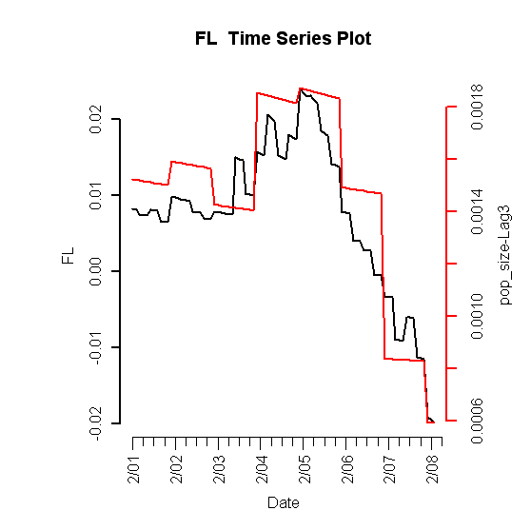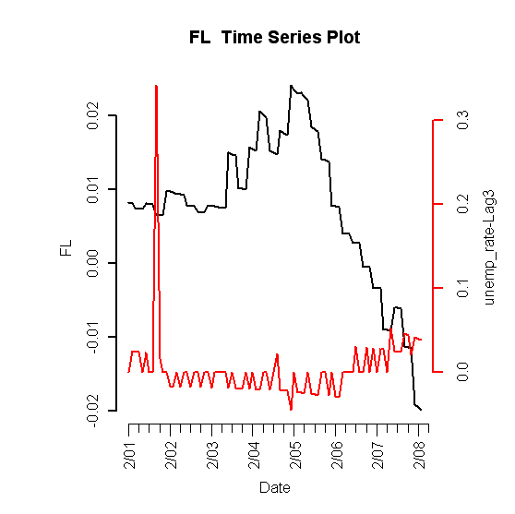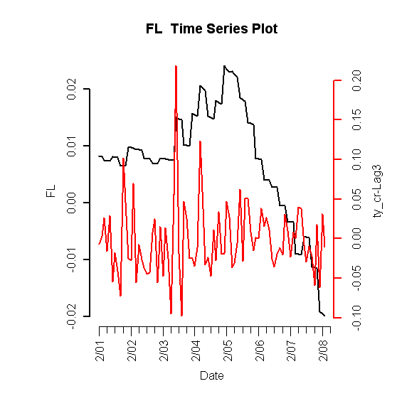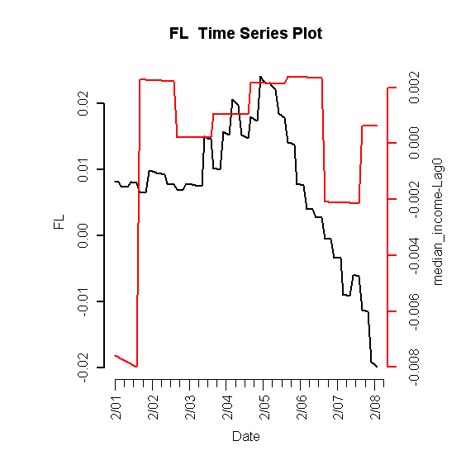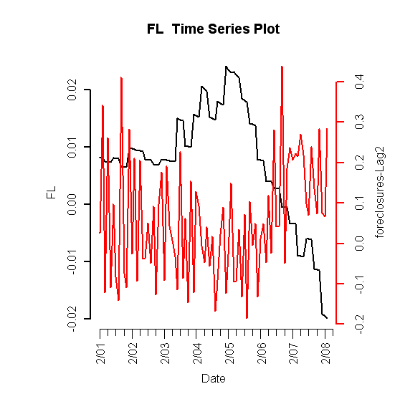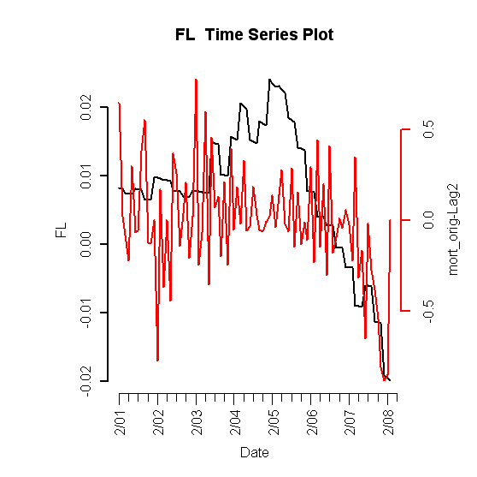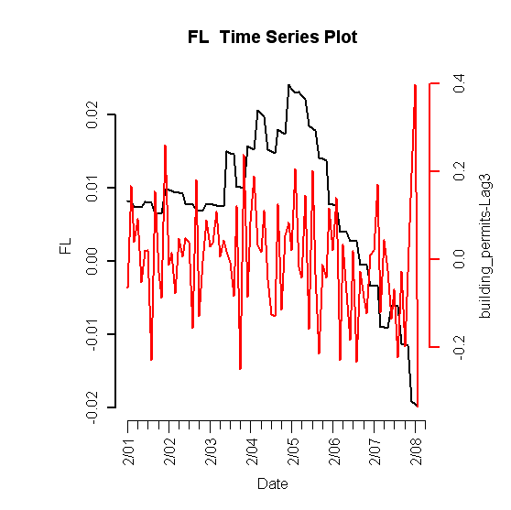
Figure III.24: Lagged predictors vs. Florida HPI

c. Final Multivariate Model

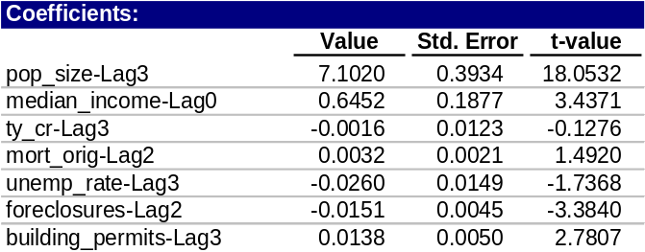
Table III.9: Fitted drift model

1. Phase I: Drift Model

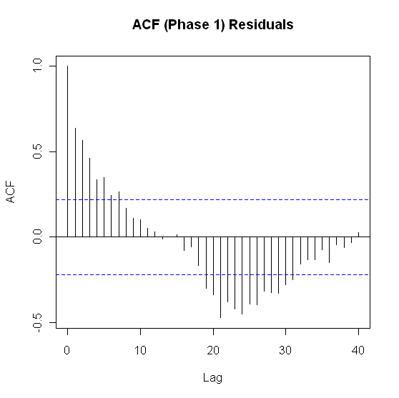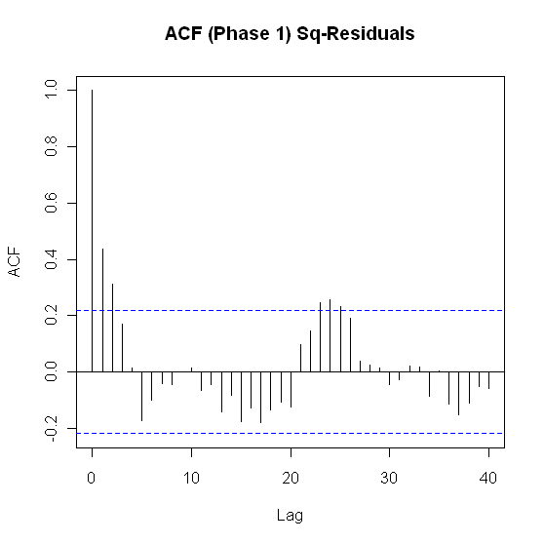
Figure III.25: ACF of residuals (left) and squared residuals (right) of fitted linear model

2. Phase II: Volatility Model

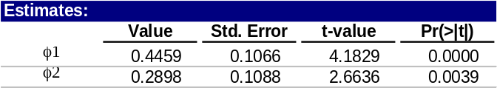
Table III.10: Florida fitted volatility model

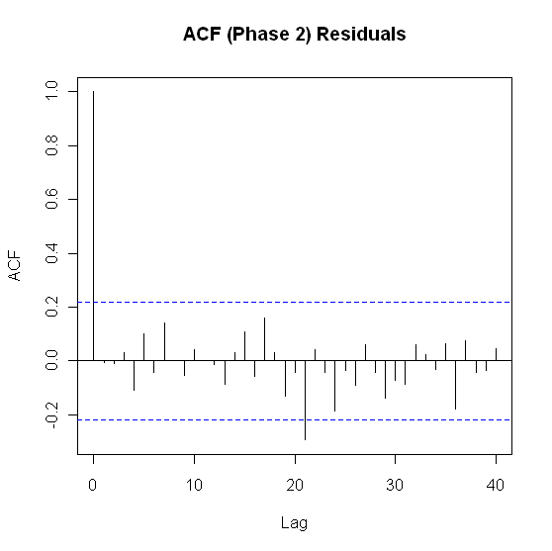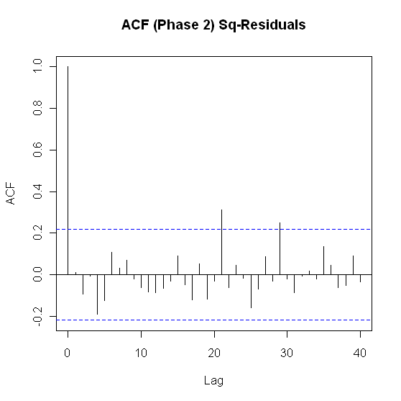
Figure III.26: ACF of residuals (left) and squared residuals (right) of the Phase II model for Idaho

3. Model Checking Diagnostics

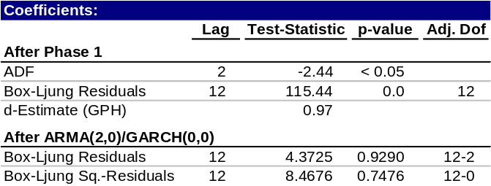
Table III.11: Statistical test results for complete model

d. Fitted vs. Actual Plots

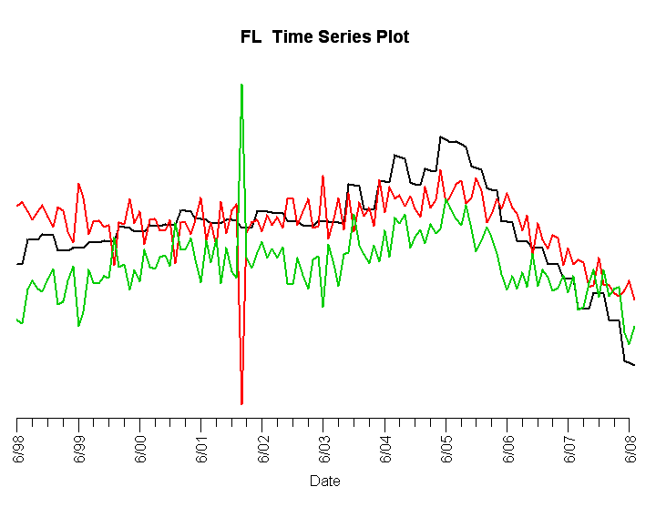
Figure III.27: Fitted Phase I (red) vs. Florida HPI and residuals (green)

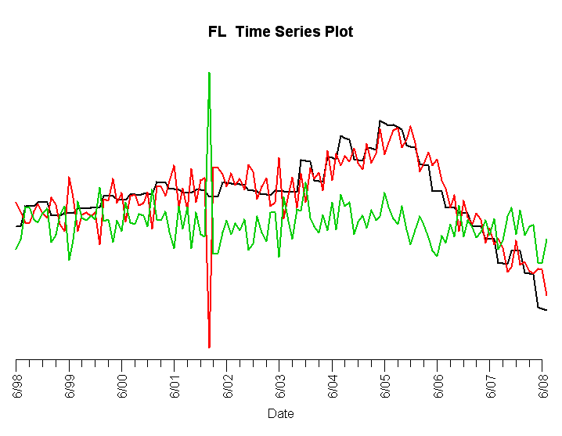
Figure III.28: Complete fitted model (red) vs. Florida HPI and residuals (green)

Figure III.27 and Figure III.28 show that the fitted models provide a good fit for the simple returns of Florida’s HPI, with the exception of a spike in late 2001. This is due to the dramatic and unexpected rise in unemployment due to the 9/11 terrorist attacks. Florida was more negatively affected by September 11 since one of its core industries, tourism, was strongly impacted. Neither the drift nor volatility models are able to capture this anomalous event.

e. Forecasts

Population size has historically had a large effect on the state’s housing prices before the housing bubble, and foreclosures less of an effect. Going forward, demand for housing will be less influenced by growing population size, and supply for housing measured by amount of housing inventory is expected to be more effected by foreclosures. To account for this difference in the supply and demand dynamics, an adjustment was made to these variable’s forecasts, and hence this altered the final forecast for Florida’s HPI.

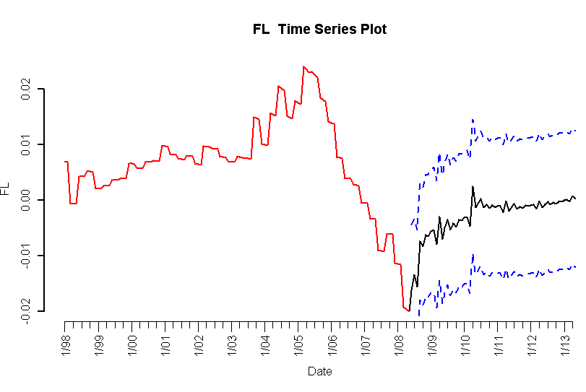
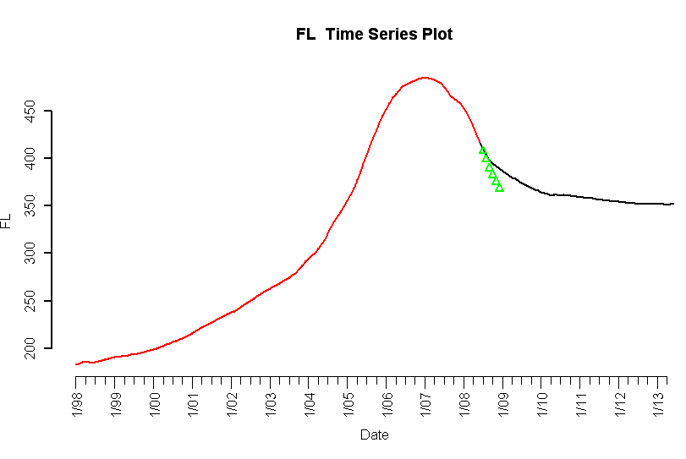
Figure III.29: 5-year forecasted simple returns (top) and forecasted HPI (bottom)

f. Interpretation of Forecasts

The forecast for Florida shows continued decreasing prices, but at slower rates until the end of 2009, and a recovery in mid 2010.

Amongst the bubble states, our forecast and outlook for Florida is quite positive. There are optimistic outlooks for Florida’s population growth, unemployment rate, median income, and housing inventory, all of which are important predictors for Florida’s future housing prices.

Florida’s housing market peaked in 2005, before any other state in the U.S. Many real estates experts and analysts believe that Florida will also be the first to see a recovery as well. A popular expression for this belief is “First in, first out.”

Population growth is estimated to remain strong for the state. By 2010, Florida is forecasted to be the third most populated state in the nation. Florida’s population is expected to increase about 75% by 2030. An estimated 900 people move to the state every day.

Florida has the 4th largest labor force and its unemployment rate has been historically below national average for the past decade as shown in Figure III.30.

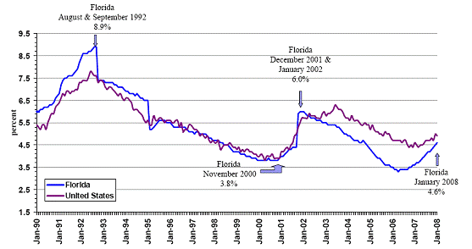
Figure III.30: Seasonally Adjusted Unemployment Rates

Florida also has no state income tax. This gives an extra boost to median income, which has a positive relationship with housing prices.

There have been current signs of inventory reduction. Despite the fact that hundreds of foreclosed properties go on the market each month, the inventory of houses for sale is shrinking. There is current 12-month supply of inventory, down from a peak of 30 months. 3-6 months supply is typical of a healthy housing market.

Furthermore, steep price declines have encouraged first-time homebuyers with good credit, and lots of investors. Cash-rich international investors are also taking advantage of the depressed prices. First and second quarter 2009 has seen housing prices beginning to flatten out.

4. Texas
a. Introduction
Texas is fundamentally immune from housing price bubbles, and there are a few key insights that can explain the historically behavior and future projections. Historically and presently, foreclosure rates have been much lower than the national average. However, an exception occurred in the 80’s when Texas experienced an energy bubble, and nine out of the ten largest banks in Texas collapsed due to the subsequent real estate crash. As a result, the credit quality of mortgages have fared better due to stricter lending standards and explicit restrictions on prepayment penalty clauses [2].
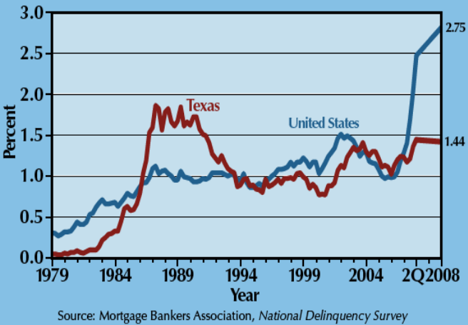
Historical Mortgage Foreclosure Rate
Figure IV.31: Historical mortgage foreclosure rate in Texas and the United States.

Recently, Texas has experienced a very low foreclosure rate compared to the nation in the midst of the current housing bubble and correction. The notion that there are two Americas—the coastal regions with dense population densities with zoning and land permit restrictions, and the center states like Kansas, Oklahoma, and Texas—gives rise to the conclusion that speculation and dense populations in states like Florida creates an inelastic supply, and a situation where housing bubbles and happen as a result of lower lending standards and relatively limited housing supply [1].
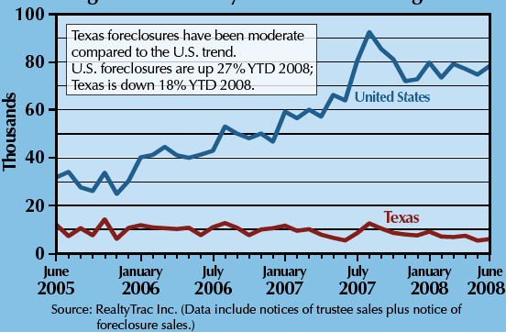
Recent Mortgage Foreclosure Rate
Figure IV.32: Recent mortgage foreclosure rate in Texas and the United States.

b. Plot of Lagged Predictors vs. HPI (simple returns)
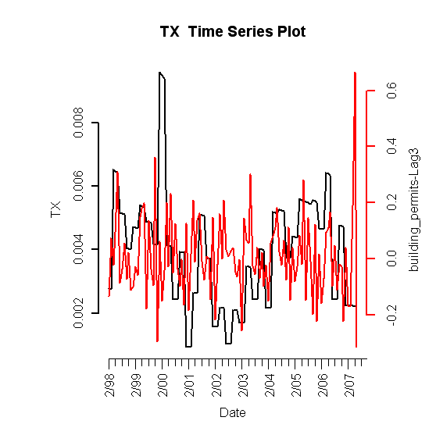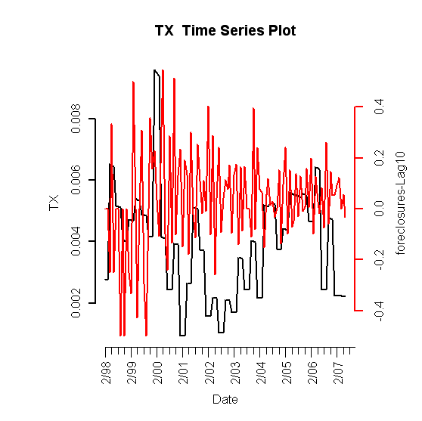
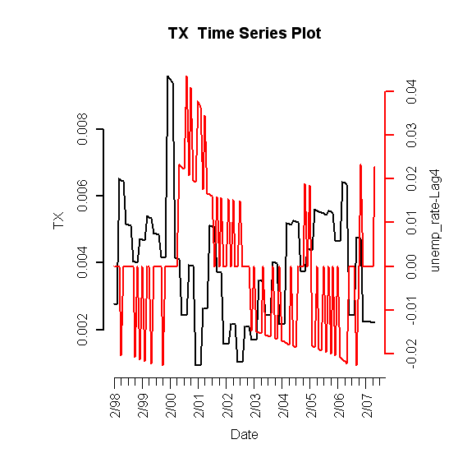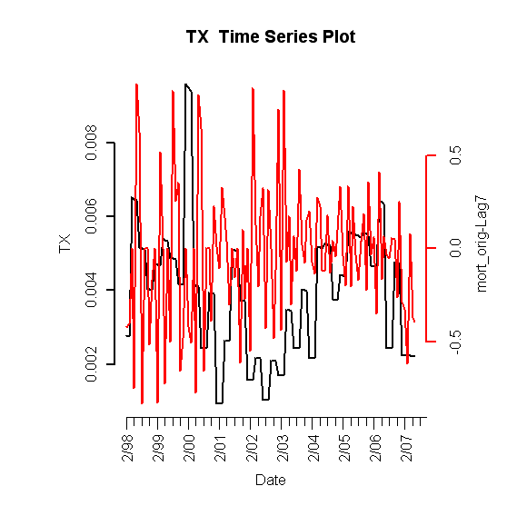
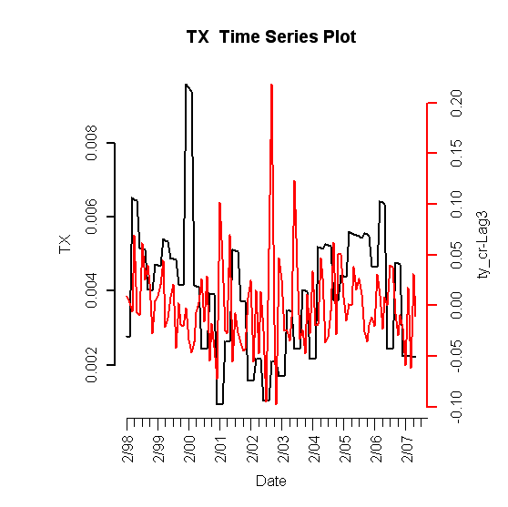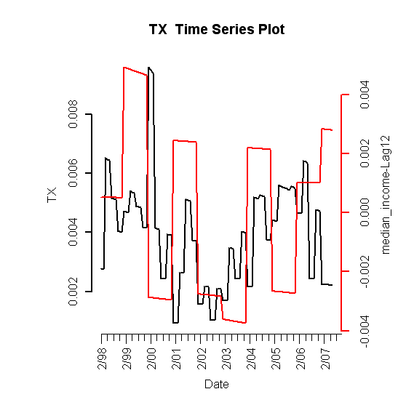
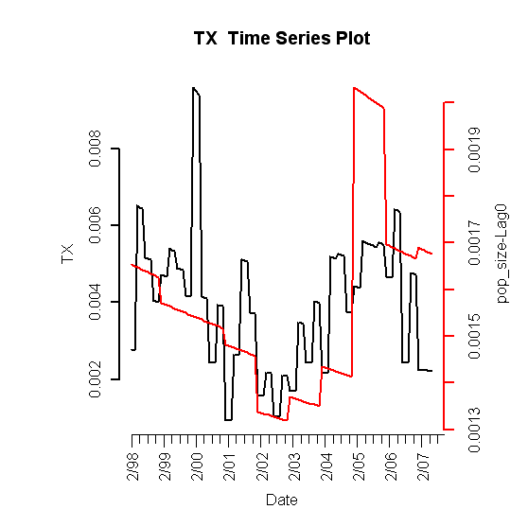

Figure IV.33: Lagged predictors vs. Texas HPI

c. Final Multivariate Model

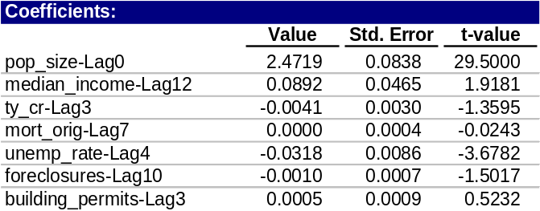
Table 12: Fitted drift model

1. Phase I: Drift Model
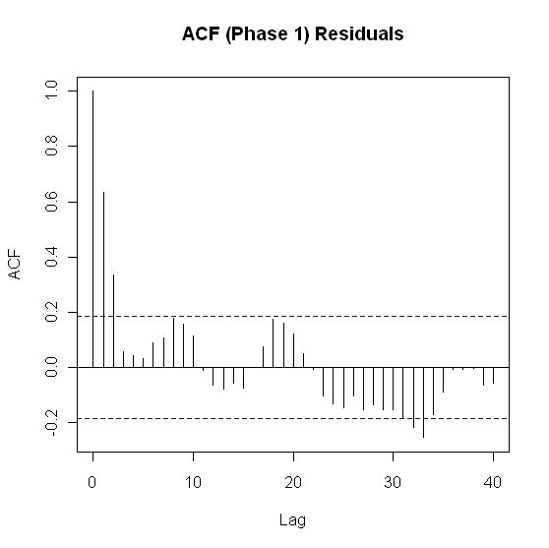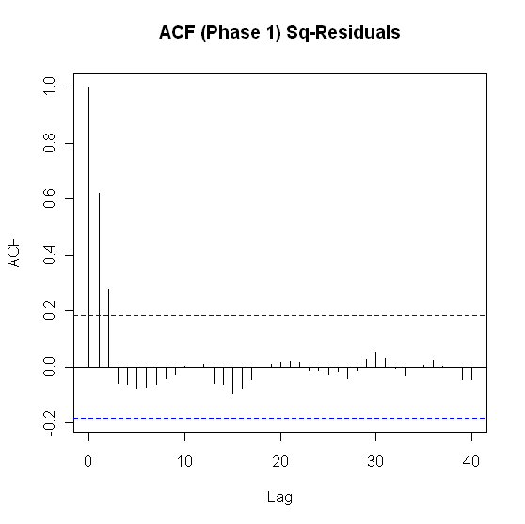

Figure IV.34: ACF of residuals (left) and squared residuals (right) of fitted linear model

2. Phase II: Volatility Model

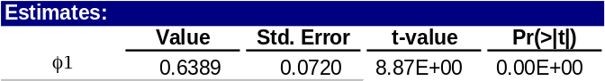
Table 13: Texas fitted volatility model
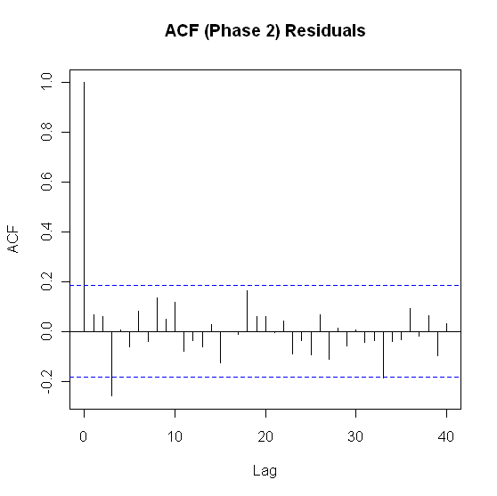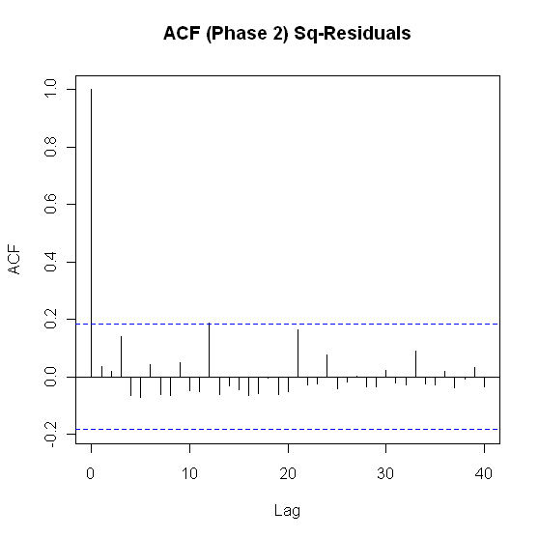

Figure IV.35: ACF of residuals (left) and squared residuals (right) of the Phase II model for Texas

3. Model Checking Diagnostics
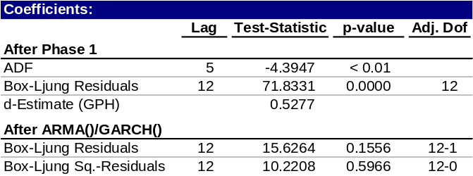
Table 14: Statistical test results for complete model

d. Fitted vs. Actual Plots

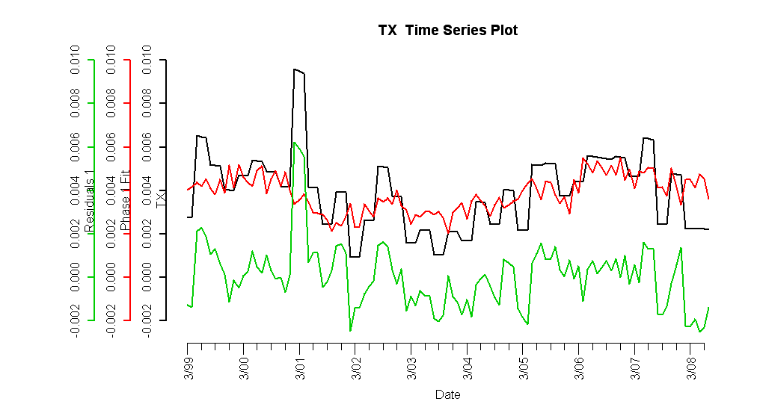

Figure IV.36: Fitted Phase I vs. Texas HPI and residuals

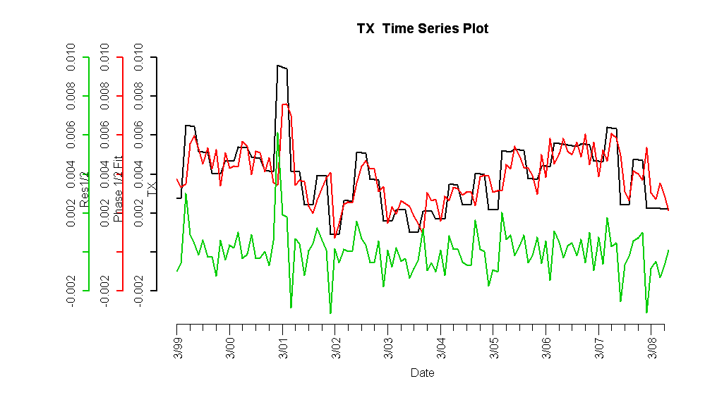

Figure IV.37: Complete fitted model vs. Texas HPI and residuals
e. Forecasts

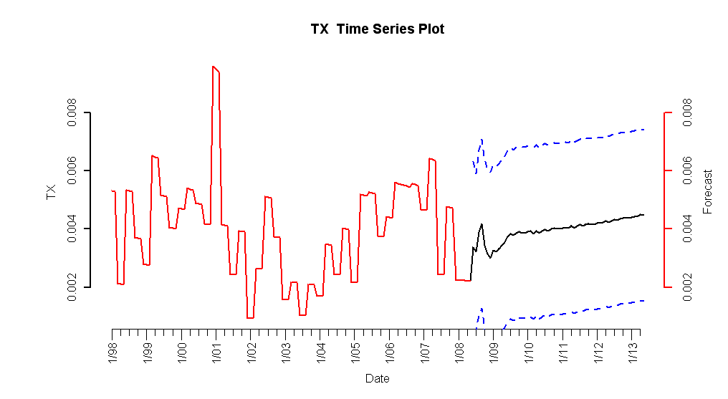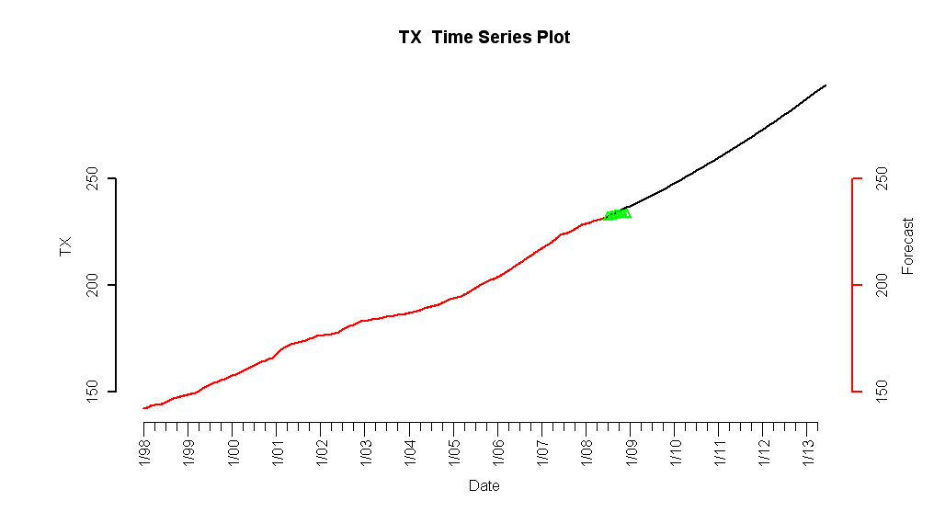
Figure IV.38: 5-year forecasted simple returns (top) and forecasted HPI (bottom)

f. Interpretation of Forecasts
The Texas HPI simple return five-year forecasts show a modest positive monthly increase relative to historical simple returns. At 0.5% monthly appreciation, houses will exhibit an annual appreciation of approximately 3%, which is slightly above inflation. Consequently, historical trends in the HPI itself are expected to continue, although at a slightly slower rate. Although construction has slowed considerably in Texas, this will have the effect of keeping inventories from spiking and keeping housing prices stable, if not moderately increasing over the next five years [3].

5. Montana

a. Introduction

Montana was one of the last hold-outs in the nation's financial crisis. The state had one of the highest employment rates in the nation due to growth in the energy industry, but as natural gas companies curtail operations housing markets will feel the impact. Thousands who work in the energy fields are fleeing the state. However, comparatively fewer foreclosures in Montana will also act to soften the blow.
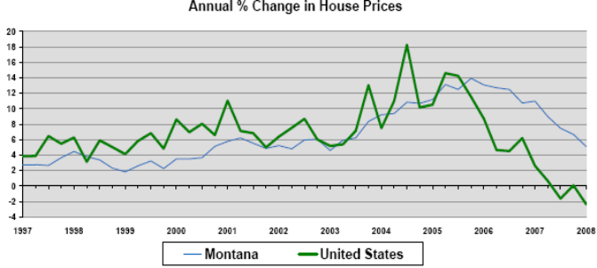
Source: Freddie Mac's Conventional Mortgage Home Price Index

Employment Growth
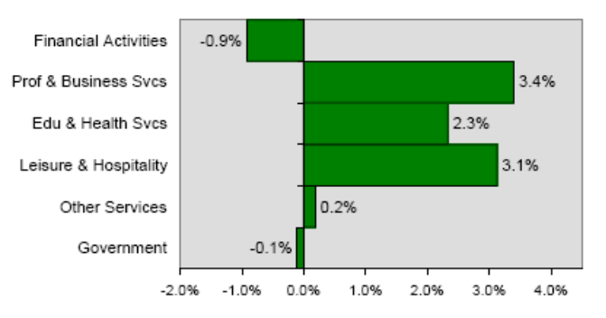
Source: Bureau of Labor Statistics, % change year ago

A vigorous expansion over the last 20 years has produced a growing business community in Missoula. But the national recession is putting a damper on Missoula. A sixth of the community's population now lives under the poverty line making it impossible for them to become homeowners. After 15 years of housing values going up, Missoula is forecast to deflate 4.5% for the year.

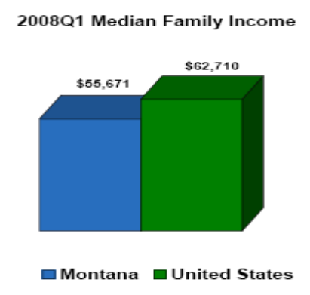
Source: US Census Bureau, Moody's Economy.com

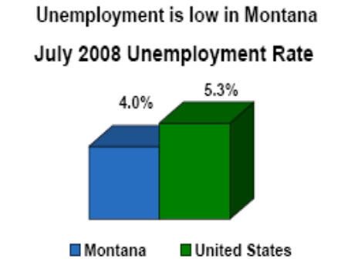
Source: Bureau of Labor Statistics

Montana has been largely isolated from national trends. There wasn't much subprime or creative financing offered during the nation's real estate boom in Montana with Alt A adjustable rate mortgages, which acted to at least protect the state's markets.

Bozeman has one of the highest numbers of home businesses in the country with many of its residents tied to the development of the growing World Wide Web, and it's constantly rated as one of the most live-able cities in the country for entrepreneurs. With just under 50,000 residents, Bozeman offers amenities usually found in larger urban settings and plenty of year round outdoor activities. Bozeman's attraction should endure the economic downturn as housing sales turn sluggish with values forecast to decline just 2.8% through the year's end.

Montana Leads 2009 Top Housing Market Forecast.

b. Plot of Lagged Predictors vs. HPI (simple returns)
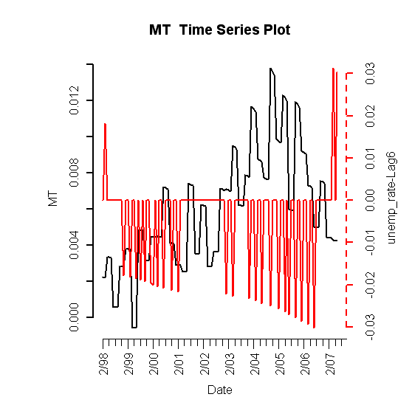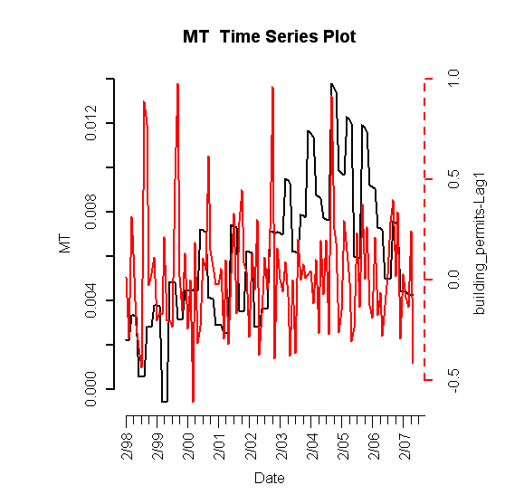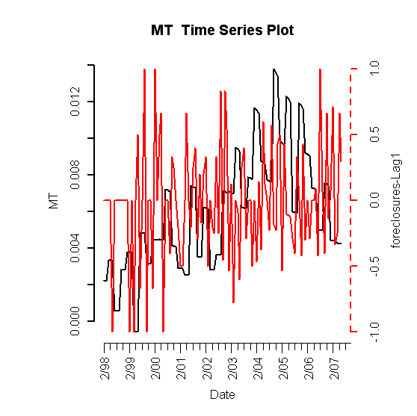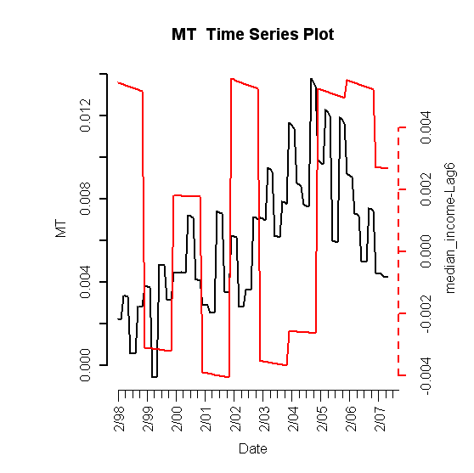

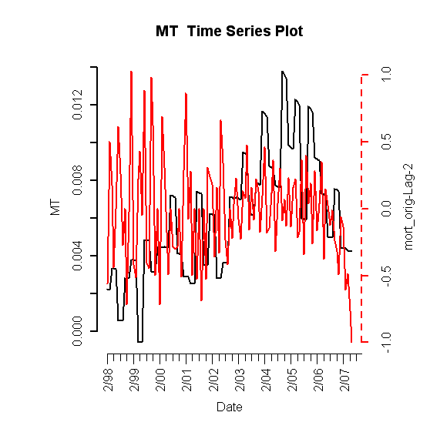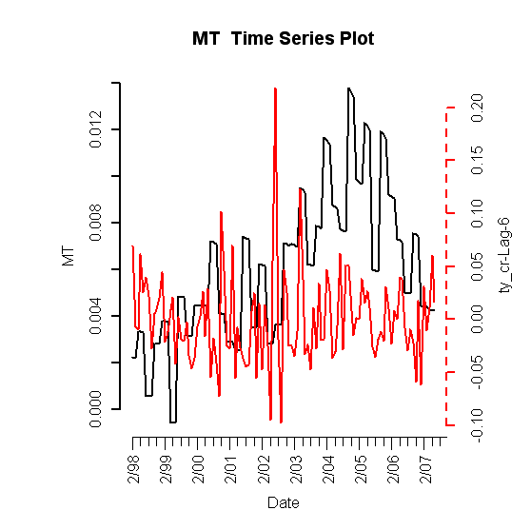

Figure V.39: Lagged predictors vs. Montana HPI

c. Final Multivariate Model

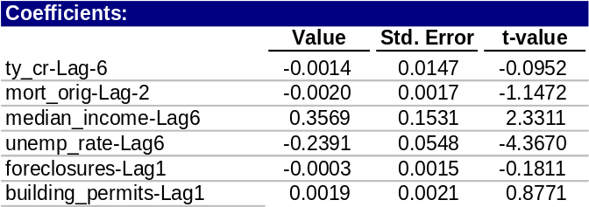
Table 15: Fitted drift model

1. Phase I: Drift Model

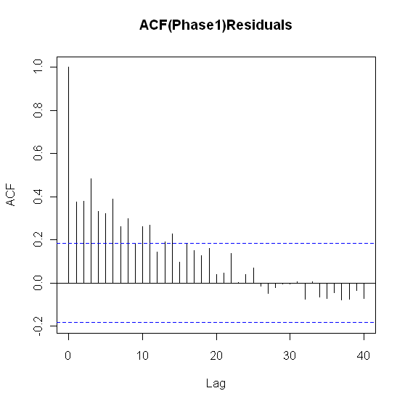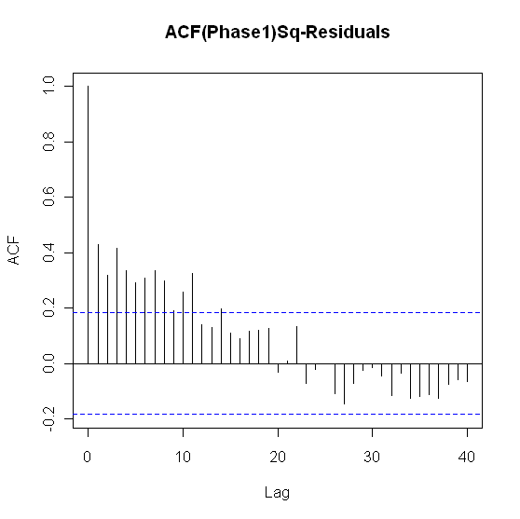
Figure V.40: ACF of residuals (left) and squared residuals (right) of fitted linear model

2. Phase II: Volatility Model

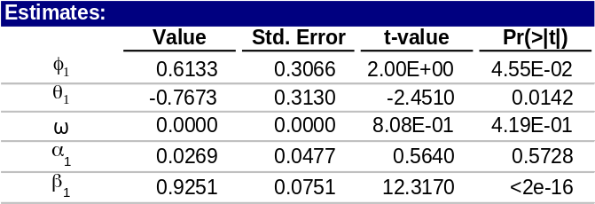
Table 16: Montana fitted volatility model

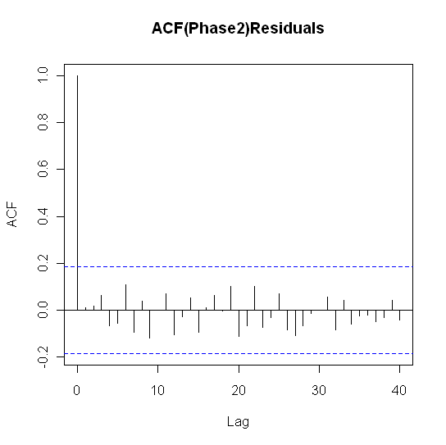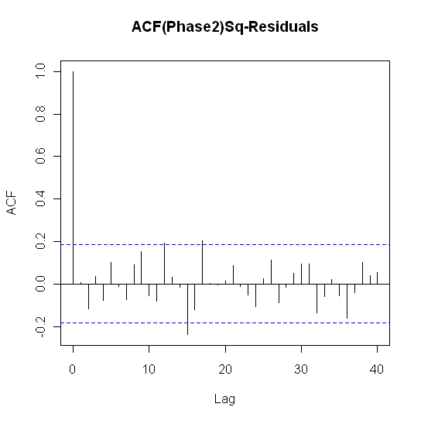
Figure V.41: ACF of residuals (left) and squared residuals (right) of the Phase II model for Montana

3. Model Checking Diagnostics

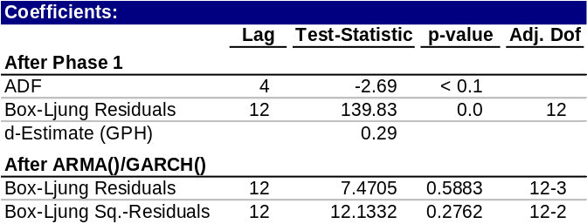
Table 17: Statistical test results for complete model

d. Fitted vs. Actual Plots

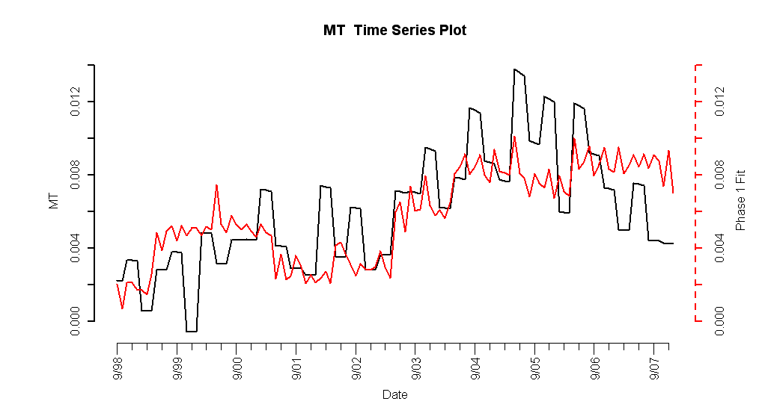
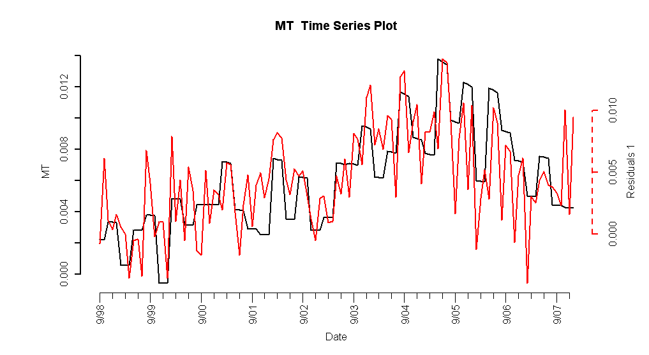
Figure V.42: Fitted Phase I vs. Montana HPI (top) and residuals (bottom)

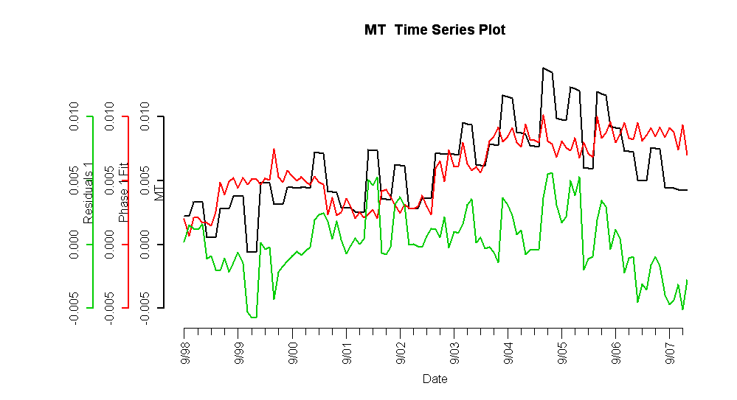

Figure V.43: Fitted Phase I vs. Texas HPI and residuals

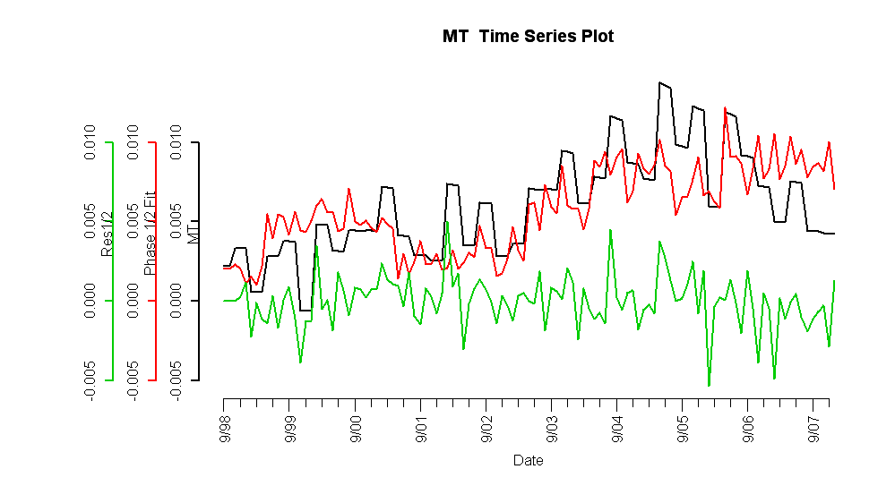

Figure V.44: Complete fitted model vs. Texas HPI and residuals

e. Forecasts
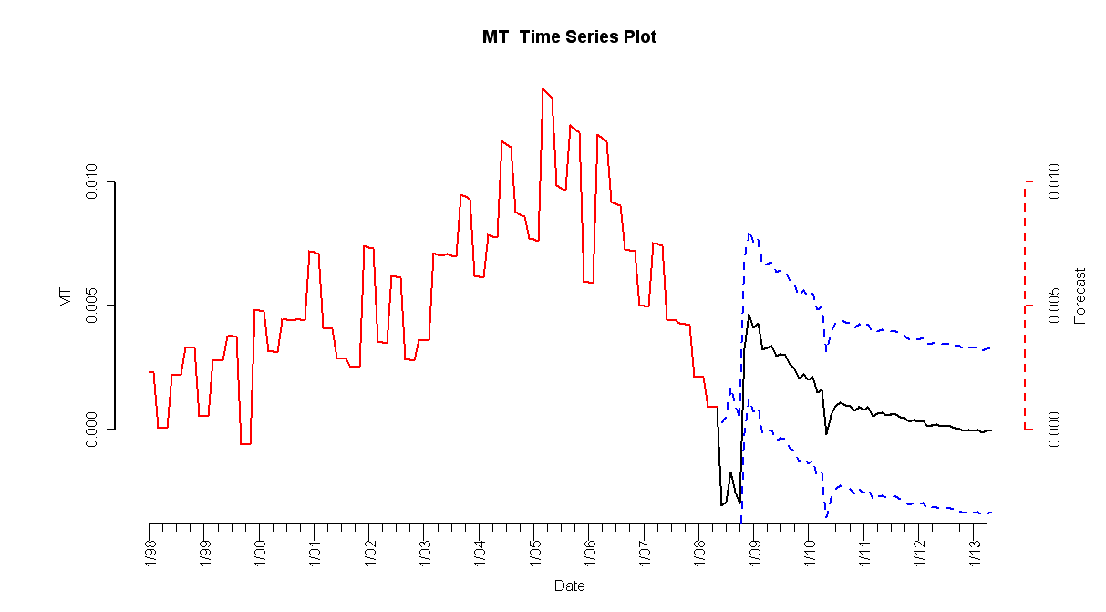

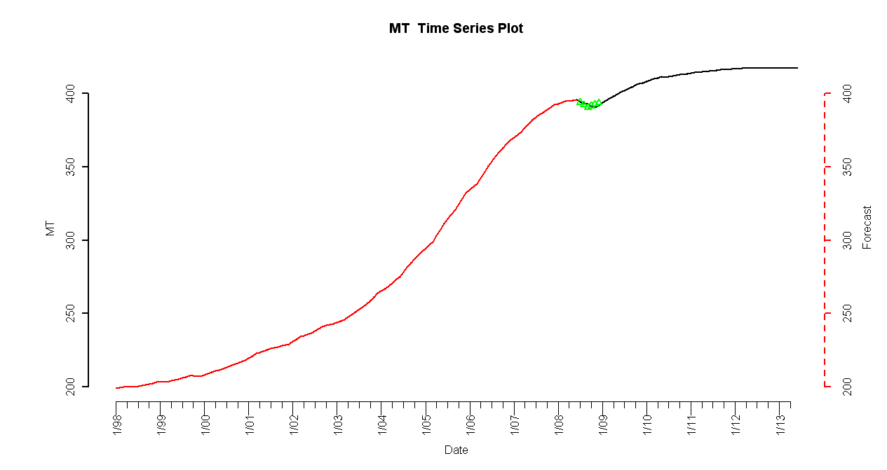
Figure V.45: 5-year forecasted simple returns (top) and forecasted HPI (bottom)

C. Aggregate State Results

***

Regarding the fives states discussed in detail, the year-on-year percentage change in forecast results are consistent, shown in Figure 1.1.1 to Figure 1.1.5.

Arizona is plagued with foreclosures with a large supply of housing stock. The HPI is expected to see sharper declines in the near term, with a grim outlook for the next five years in regards to a strong recovery. The Arizona housing market will level off as the natural economic forces create an equilibrium, but the reliant of the state on three recessionary industries will prevent the state from making a near term comeback.

California is expected to have some reprieve due to state government assistance. Based on the year on year percentage change analysis, the change in HPI will level off. The high unemployment and high defaults will cause a fall in the two-year year-on-year percentage change, which will rebound in subsequent years to stabilize prices.

Texas’ low foreclosure rate contributes to the short term gains, as well as the strong base of Fortune 500 companies. The consistency of growth in the state contributes to the steady year-on-year % positive change in forecast. There would have to be a major disruption in the state economy to cause a significant impact, i.e. a technological change or natural disaster.

Montana’s growing energy industry and highest employment rate contribute to their growing HPI. The energy industry is speculated to grow as alternative sources are sought, causing an increase in year-on-year percentage change in forecast.

Florida has seen extreme losses since the subprime crisis has occurred, and it will take quite a few years for their HPI to turn around. The year-on-year percentage change in forecasts is sensible, as their market has potentially bottomed out. However, it will be quite some time until they see gains in the absolute level of their HPI. As the economy returns to equilibrium, the simple returns will rapidly converge to 0, as indicated by the substantial year-over-year positive percentage change in forecasts.

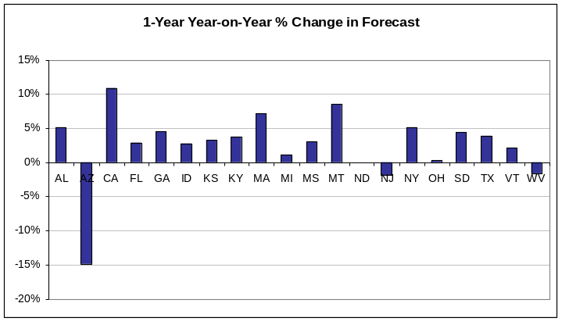
Figure 1.1.1: One-Year Year-on-Year % Change in Forecast

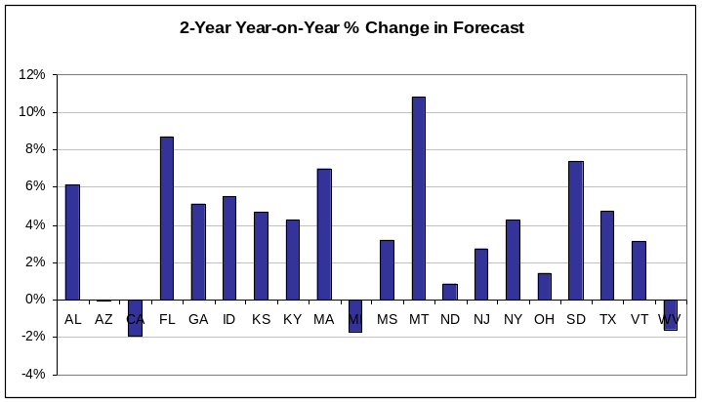
Figure 1.1.2: Two-Year Year-on-Year % Change in Forecast

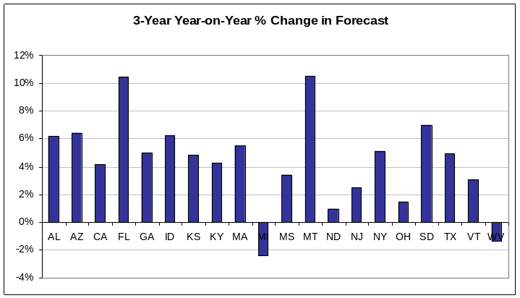
Figure 1.1.3: Three-Year Year-on-Year % Change in Forecast

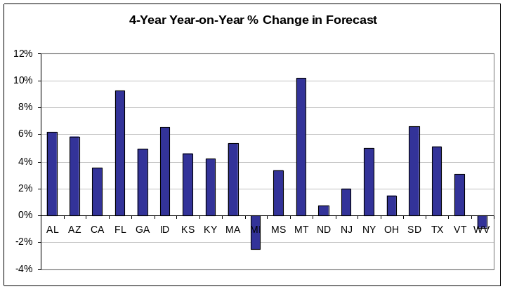
Figure 1.1.4: Four-Year Year-on-Year % Change in Forecast

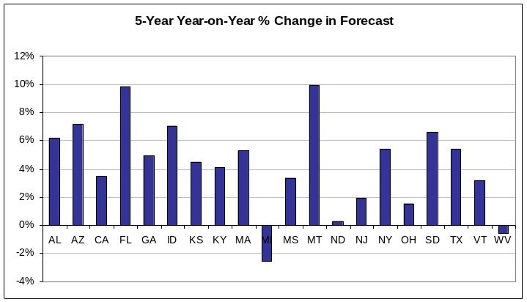
Figure 1.1.5: Five-Year Year-on-Year % Change in Forecast

D. Temporal Holdout Verification

As a more interesting point, a big question faced is whether this modeling technique would have predicted the subprime bubble of 2007. Temporal holdout was performed to backtest the model accuracy and investigate the answer to this question. The software was recoded to use the end of second quarter 2006 as the end horizon. The only change in our models was that the coefficients were re-estimated to reflect the truncated data set. Curve fitting of the predictors was performed using only data from the middle of 2006 with the same methodology as done for the middle of 2008.

The national home sales and prices both fell dramatically in March 2007; the steepest plunge since the 1989 Savings and Loan crisis. This is why backtesting the forecasting ability from the middle of 2006 is important: to determine if the bubble burst may have been predicted several quarters in advance.

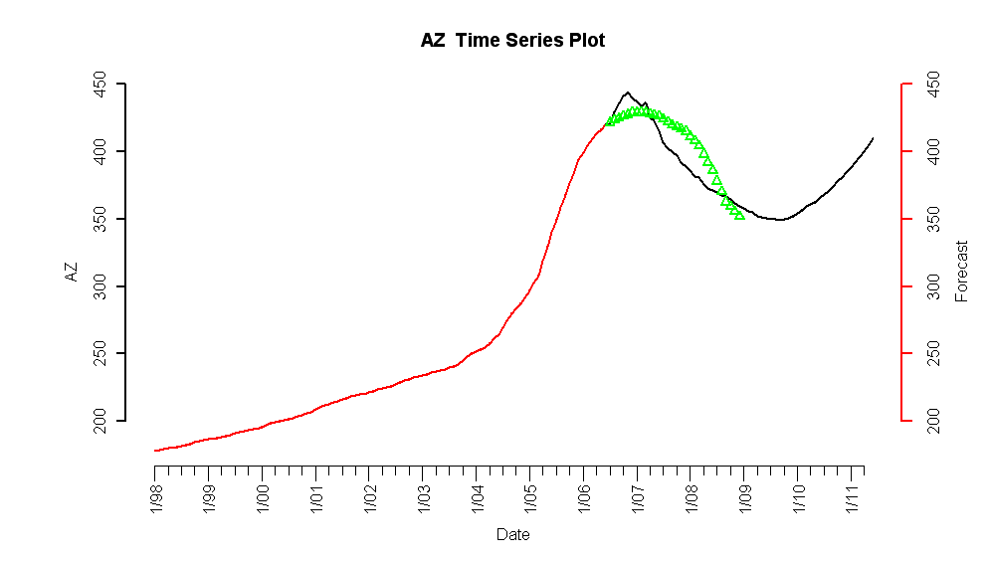
Figure 1.1.1: Temporal Holdout Verification for Arizona

Arizona is one of the states that face a large housing bubble with currently the third highest foreclosure rate in the nation. The temporal hold verification in Figure 1.1.1 indicates the model predicted a peak in the Arizona HPI in third quarter of 2006 while the actual peak occurred in first quarter of 2007. With the benefit of observed data through 2008, the model predicted relatively well the magnitude and slope of decline. The bottoming out of the HPI in mid 2009 may actually be a reality with the steps the Obama administration has taken, as well as the recent recovery of the equity markets.
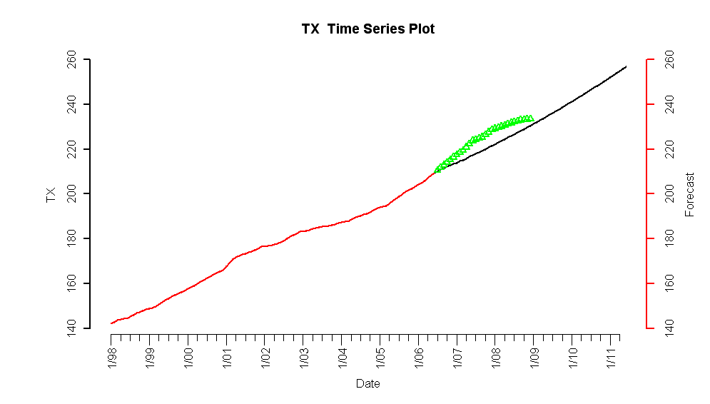

Figure 1.1.2: Temporal Holdout Verification for Texas
Texas was an interesting candidate for temporal holdout verification as their HPI was one of the few that were not subject to the repercussions of the subprime crisis. As shown in Figure 1.1.2, forecasts indicate a relatively steady increasing HPI. The forecast was actually on the conservative side; understating the returns of the true HPI. However, the values appear to be converging as 2009 progresses.

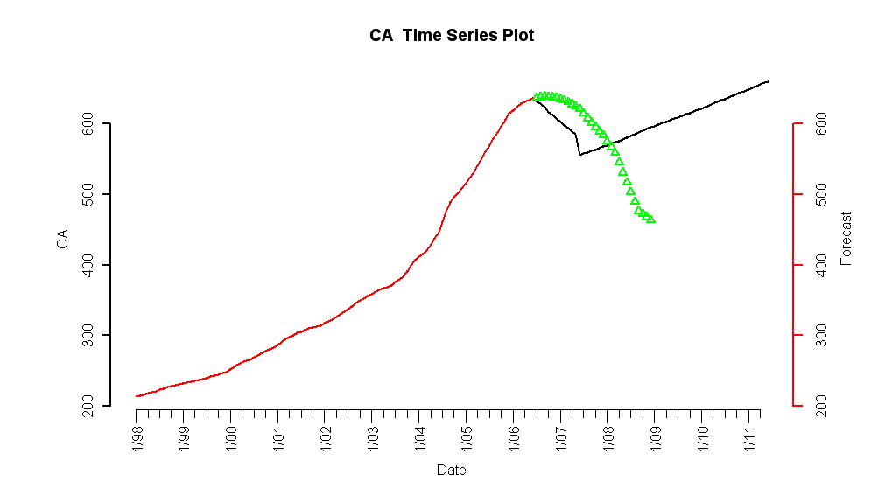
Figure 1.1.3: Temporal Holdout Verification for California
California has state economics similar to Arizona, and is facing an even higher foreclosure rate. As a state subject to a large speculative bubble, temporal holdout verification had an interesting result. Shown in Figure 1.1.3, the forecasts predicted an immediate drop in the HPI from the forecast horizon with a turnaround in the middle of 2007. The timing of events did deviate substantially from their actual occurrences, but direction of change was initially predicted. However, as more observable data became available the coefficient estimates could be re-estimated to provide better forecasts.
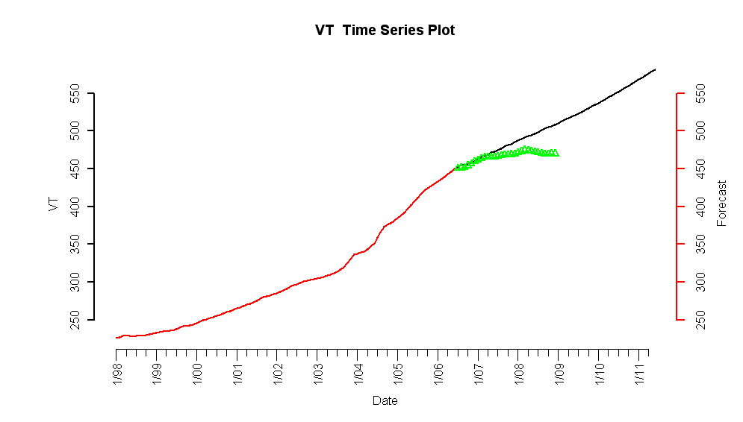
Figure 1.1.4: Temporal Holdout Forecast for Vermont

Vermont was an interesting case study where the HPI leveled off in the last couple years. As shown in Figure 1.1.4, forecasts following the observed value through the first quarter of 2007. However, at this point the HPI has remained steady while the forecasts indicated an increasing trend. The noteworthy fact remains that the three quarters of forecasting bared remarkable prediction power. A near term rebound could cause the observed values to converge; however, large gains are unlikely.

Temporal holdout validation was performed on other states – the results are similar to one of the scenarios previously presented.
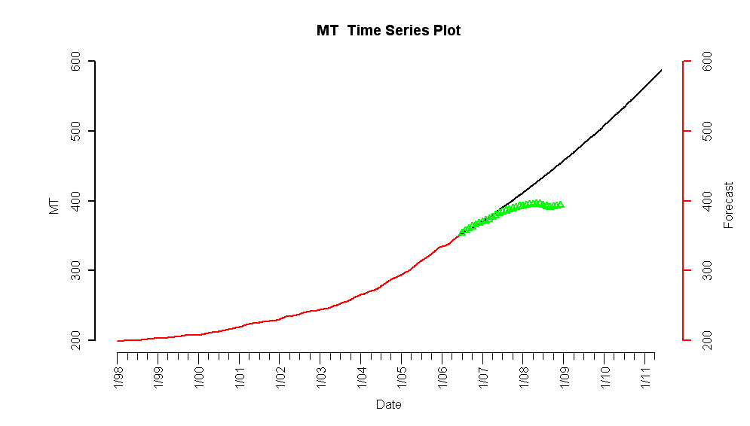
Figure 1.1.5: Temporal Holdout Forecast for Montana

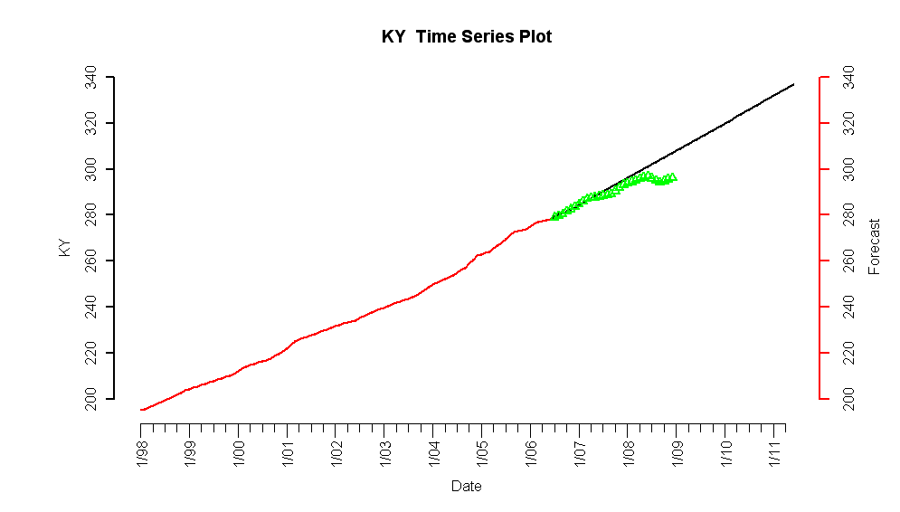
Figure 1.1.6: Temporal Holdout Forecast for Kentucky

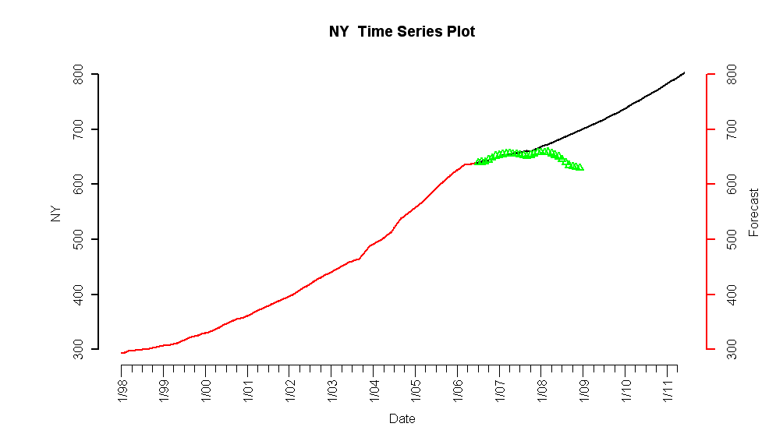
Figure 1.1.7: Temporal Holdout Forecast for New York

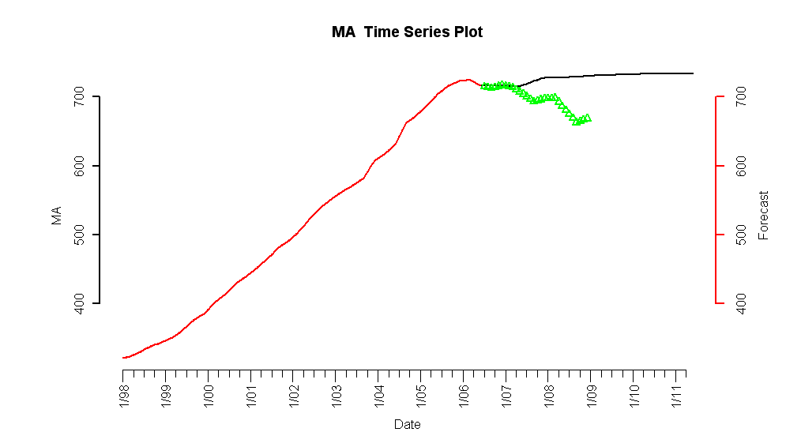
Figure 1.1.8: Temporal Holdout Forecast for Massachusetts

E. Modeling Challenges

During the modeling process, some challenges were faced with regards to a few aspects.

For one, the data itself posed problems when attempting to model the HPI:
- As mentioned earlier, there were questions about the accuracy of the HPI data before the 1990 period, as well as the collection methodology. The inaccuracy of the data may lead to occurrences of influential observations, or outliers. These outliers in turn may hinder the stationarity of residuals, which is a requisite in fitting the models. To account for any influential observations that occurred, we used the Grubb’s test to remove any these points.
- The frequency of the data also varied among the 7 variables as well as the predictor variable. While the goal was to obtain monthly forecasts, many of the data was available in different frequencies, like monthly and yearly. For example, population size is only available yearly from the US Census Bureau, while the HPI from OFEHO is only available in quarterly intervals. Thus, linear interpolation was used to match the frequency of data across all response variables.
- While the seven variables were chosen, the temporal relationship needed to be determined. Variables were determined to be either leading or lagging, which explained in what capacity they predicted the HPI. Multiple lags of each variable were tested to determine which one best overlapped with the HPI.

Another modeling challenge with actually determining the regression coefficients. The t-statistic was used to determine statistical significance of the drift model coefficients. However, using the t-statistic requires the assumption that the coefficients were normal. To account for this difficulty, temporal holdout and plotting the predicted vs. actual were used to test the accuracy of the model. We ensured the remaining variables were significant, as taking away additional variables would affect the accuracy of the predicted values.

Further, some constraints were imposed while modeling the drift component of the HPI. One constraint was that the model had to be parsimonious; that is, there could be only one lag for every predictor variable. Thus, insignificant variables were removed one at a time, until one lag remained for each predictor variable. In addition, the coefficients had to follow economic intuition. The seven macroeconomic variables either have a positive or negative relationship with the HPI. Thus, the signs of the coefficients had to match with the positive/negative relationship that was determined for each predictor variable.

Finally, the residuals of the drift model were ensured to be stationary. Stationarity of residuals means that the drift model is time invariant, otherwise, it seems like the regression would be spurious.

F. Next Steps

Energy prices should be investigated as a predictor of housing prices. The only challenge that carefully needs to be examined is the ability to forecast a proxy for energy prices, i.e. crude oil. With an asset difficult to forecast, adding the predictor may spiral into a project in itself. In a study published by Molly Longstreth in the Journal of Consumer Affairs, natural gas consumption did not affect home sale prices in the period 1971-1976, but higher consumption levels reduced sale price per square foot in the period 1977-1980 up to $88 ccf/sf year [1]. Longstreth determined at higher levels the sale price rose with increases in gas consumption. The economic rationale is that buyers’ and sellers’ expected present values of housing operating costs change with energy costs. Moreover, it is expected that states with extreme climates will be more sensitive to changes in energy costs than those with moderate climates.

There probably exists a cointegrating factor between many of the states, which would allow multiple states to be modeled simultaneous. The simple returns for many of the predictors with state level data have similar values, indicative of a cointegrating factor. Many of the states HPI have similar evolution through time, i.e. Arizona, California, and Nevada which are all currently experiencing high levels of foreclosure. States such as Montana and Vermont have had similar leveling trends in their HPI without the geographical similar of the previous example.

Options and futures based on Case-Shiller index are traded on the Chicago Mercantile Exchange, which may serve as a reliable indicator of future housing prices. However, the liquidity of these assets needs to be taken into consideration. If deemed appropriate, these may serve additional value if the housing price index forecasts are used in a trading model. These futures would be a potential cointegrating factor, and may serve as a reason to use the Case-Shiller index as a response.

Monte Carlo simulation could be incorporated into the temporal holdout to provide an indication of model accuracy for historically observed HPI. This would be a simple addition since the standard error for the forecast simple returns is produced by the model. Additionally, simulating the predictors may provide a better understanding of the return distribution, especially considering the limitations of being able to predict economic factors.

Conclusion

The majority of the states’ simple return series were determined to be stationary based on Augmented Dickey-Fuller and Phillips-Perron test results. Furthermore, the simple returns do not follow a Gaussian distribution and a Box Cox transformation is ineffective in making the return series normal. Some of the exhibited non-normality may be a result of ARCH effects; however, this may be remedied by GARCH modeling, which will be further investigated. Simulation shows that the density of the GPH-estimated fractional differencing parameter d appears to be light-tailed and symmetric about its true value.

In analyzing each state’s simple returns, interpolated linearly from quarterly to monthly, and cutting-off data before T=40, we observe adequacy of ARFIMA(p,d,q)+GARCH(m,s), for m=3,s=1. Using temporal holdout and Box Jenkins, we can approximate the adequacy and performance of these models over time

References

http://mises.org/journals/scholar/Thornton13.pdf
http://federalreserve.gov/releases/h15/data/Monthly/H15_PRIME_NA.txt
Census.gov –building permits issuance
Beran, Jan. Statistics for Long Memory Processes. p.144.
Dolando, J. “A Fractional Dickey Fuller Test for Unit Roots.”
Sephton, P. “Critical Values for the Augmented Factional Dickey Fuller Test”. 4 G.N. Fouskitakis and S.D.Fassois. “A Pseudo Linear Method for Fractionally Integrated Arma (ARFIMA) Model Estimation.” ⁵ Jeffrey S. Pai, Nalini Ravishanker. “A Pseudo Linear Method for Fractionally Integrated Arma (ARFIMA) Model Estimation.” 6 Zazli Chik Pusat Asasi Sains, “Performance of Order Selection Criteria for Short Time Series” 7 Yuhong Yang, “Can the Strengths of AIC and BIC Be Shared” 8 Mankiw. Principles of Economics. Souther-Wester College Pub, 2003. References - (New York Times Online) P. Krugman. (2007, October, 7). The two Americas [website]. Available: http://krugman.blogs.nytimes.com/2007/10/20/the-two-americas/ - (Portfolio.com) R. Avent. (2009, April, 21). The two Americas [website]. Available: http://www.portfolio.com/views/blogs/market-movers/2009/04/21/texas-housing-markets-special - (Research Center Texas A&M University). J. P. Gaines. (2009, April, 21). ’09 Outlook Nothing Certain but Uncertainty [website].Available: http://recenter.tamu.edu/pdf/1891.pdf References - (Credit Suisse Market Research Online) G. Lee. (2008, December, 4). Foreclosure Update: over 8 million foreclosures expected [website]. Available: http://www.credit-suisse.com/researchandanalytics/ - (Center for Responsible Lending) R. Avent. (2008, August). Updated Projections of Subprime Foreclosures in the United States and Their Impact on Home Values and Communities [website]. Available: http://www.responsiblelending.org/mortgage-lending/research-analysis/updated-projections-of-subprime-foreclosures-in-the-united-states-and-their-impact-on-home-values-and-communities.html [1] Longstreth, Molly, Anne R. Coveney, and Jean S. Bowers. 1985. "The Effects of Changes in Implicit Energy Costs on Housing Prices." Journal of Consumer Affairs 19, no. 1: 57. Academic Search Premier, EBSCOhost.

